**Workout with Friends**

**Health Monitoring for Fitness Gaming**

**16:332:567 – Software Engineering**

Report 3

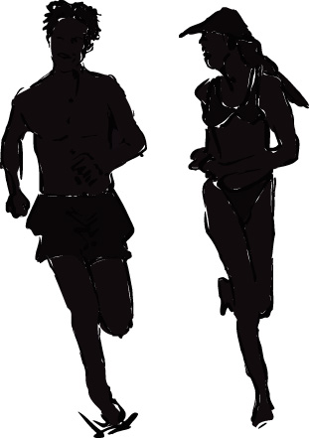

Mateus Santos

Kevin Kobilinski

Brien Range

Abdul Hassan

Daihou Wang

Sujana Gangadharbatla

https://workoutwithfriends.wikispaces.com/

**Fall 2012**

| Change Log | | | |
| --- | --- | --- | --- |
| Version | Changes Effected | Effective date | Created / Changed By |
| 1.0 | Part 1 - Initial draft version (1.0) | 12-06-2012 | Sujana G |
| 2.0 | Incorporation of Required Sections | 12-15-2012 | Brien R |

|  |  |  |  |  |  |  |  |  |  |  |  |  |
| --- | --- | --- | --- | --- | --- | --- | --- | --- | --- | --- | --- | --- |
| **Contribution Breakdown - Report 3** | | | | | | | | | | | | |
| Task | **Mateus** | **Kevin** | | **Brien** | | **Abdul** | | | **Daihou** | | **Sujana** | |
| 1) Customer Statement of Requirements |  |  | |  | |  | | |  | |  | |
| Customer Statement of Requirements | X |  | | X | |  | | | X | | X | |
| Backgrounds on Self-monitoring | X | X | |  | |  | | | X | | X | |
| Project Overview | X |  | |  | |  | | | X | | X | |
| Glossary of Terms | X | X | |  | |  | | | X | | X | |
| Editing | X | X | | X | | X | | | X | |  | |
| 2) System Requirements |  |  | |  | |  | | |  | |  | |
| Functional Requirements | X | X | | X | | X | | | X | | x | |
| Non-Functional Requirements | X | X | | X | | X | | |  | | x | |
| On-Screen Appearence Requirements | X |  | | x | |  | | |  | |  | |
| Acceptance Testing |  |  | | X | |  | | |  | |  | |
| Editing | X | X | | x | | X | | | X | | X | |
| 3) Function Requirement Specification |  |  | |  | |  | | |  | |  | |
| Stakeholders | X |  | |  | |  | | | X | |  | |
| Actors and Goals | X | X | | x | |  | | | X | |  | |
| Use Case Description | X | X | | x | |  | | | X | |  | |
| Use Case Diagram |  |  | | x | |  | | | X | |  | |
| Sequence Diagrams |  |  | | X | |  | | | X | |  | |
| Editing | X | X | | X | | X | | | X | |  | |
| 4) Effort Estimation using use case points |  |  | |  | |  | | |  | |  | |
| Preliminary Design | X |  | | X | | X | | | X | |  | |
| User Effort Estimation | X |  | |  | |  | | |  | |  | |
| Editing | X |  | |  | | X | | |  | |  | |
| 5) Interaction Diagrams |  |  | |  | |  | | |  | |  | |
| Interaction Diagrams |  |  | | X | |  | | | X | | X | |
| Editing |  | X | | X | |  | | |  | |  | |
| 6)Class Diagram And Interface Specification |  |  | |  | |  | | |  | |  | |
| Class diagram |  |  | |  | |  | | |  | | X | |
| Data Types and operation signatures |  |  | | X | |  | | |  | | X | |
| Tracebility Matrix |  |  | |  | |  | | |  | | X | |
| Design Patterns |  |  | |  | |  | | |  | | X | |
| Object Constraint language contracts |  |  | | X | |  | | |  | | X | |
| Editing |  |  | |  | |  | | |  | |  | |
| 7)System Architecture and System Design |  |  | |  | |  | | |  | |  | |
| Architectural Styles |  | X | |  | |  | | |  | | X | |
| Identifying subsystems |  | X | |  | |  | | |  | |  | |
| Mapping Systems to hardware |  | X | |  | |  | | |  | |  | |
| Persistance Data storage |  | X | |  | |  | | |  | |  | |
| Network Protocol |  | X | |  | |  | | |  | |  | |
| Global Control Flow |  | X | |  | |  | | |  | |  | |
| Editing |  |  | |  | |  | | |  | |  | |
| 8)Algorithms And Data Structures |  |  | |  | |  | | |  | |  | |
| Algorithms |  |  | | X | |  | | |  | |  | |
| Data Structures |  |  | | X | |  | | |  | |  | |
| Editing |  |  | | X | |  | | |  | |  | |
| 9)User Design Interface And Impmentation |  |  | |  | |  | | |  | |  | |
| User Design Interface And Impmentation |  |  | |  | |  | | |  | | X | |
| Editing |  |  | |  | |  | | |  | |  | |
| 10)Design Of Tests |  |  | |  | |  | | |  | |  | |
| Unit Testing |  | X | |  | |  | | |  | |  | |
| Integration Testing |  |  | |  | |  | | |  | |  | |
| Editing |  |  | |  | |  | | |  | |  | |
| 11) Project Management | | |  | |  | |  |  | |  | |  |
| Plan of Work | | | X | |  | |  |  | | x | | X |
| 12) List of References | | | X | | X | | x |  | |  | | X |

Table of Contents

1Change Log 1

2. System Requirements 19

2Non-Function Requirements 21

33. Functional Requirements Specification 27

44. User Interface Specifications 31

5. Domain Analysis 32

1. 1.1Sequence Diagrams 39
2. 2.1Class Diagrams 41
3. 2.2Tractability Matrix 44
4. 3.1Architectural Stytles 46
5. 3.2Identifying Subsystems 46
6. 3.3Mapping Subsystems to Hardware 46
7. 3.4Persistent Data Storage 46
8. 3.5Network Protocol 46
9. 3.6Global Control Flow 47
10. 3.7Hardware Rerquirement 47
11. 8.1.Algorithms 48
12. 8.2.Data Structures 51
13. 9.1.User Interface Design 53
14. 9.2.User Interface Implementation 55
15. 10.1.System Framework Tests 56
16. 10.2.Functional Units Tests 56
17. 11.2.1.Project Progresses and Plan of Work 57
18. 11.2.2.Contribution Breakdown(Report 2) 57

**1. Customer Statement of Requirements**

**1.1 Introduction**

Every January hundreds of thousands of people make it their legitimate goal to improve their overall fitness level. Although the desired targets can vary from shedding a few pounds to completing an Iron Men competition, according to fitness professionals, most people fall short from achieving their goals. Fitness Experts at Leriken Functional Fitness claims the top 10 reasons why people abandon their fitness routines are26:

1. Lack of Motivation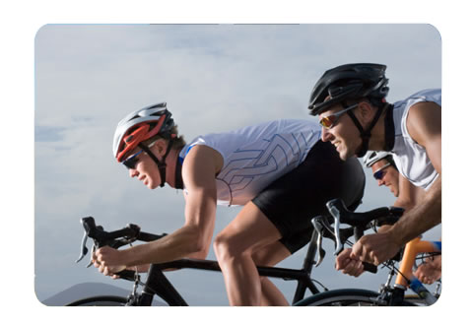
2. Setting Unrealistic Goals
3. Not Having a Clear Plan
4. Doing Too Much Too Soon
5. Pain / Injury
6. No Perceived Results or Rewards
7. Not Having Any Fun
8. Lack of Time
9. Can’t Afford the Gym Membership
10. Self-Conscious to Train in Front of Other People

**Figure 1: Friendly Competition in Cycling**

For many, staying motivated is the key to being able to stick with the commitment to pursue greater fitness level. Then there comes the self-monitoring devices from all venders, to monitor one’s physical characters during the exercises. One can simply read out your real time heart rate, blood pressure and other characters from either a bracelet like or a watch like device.

However, what self-monitoring devices can give stays at a bunch of numbers showing how much time I have exercised at a time, or how much length I may have run this time or today according to its monitoring parameters. And we’ re still looking for some application and platform to share our working out data, and to set up a more intuitive goal by completing with a friend, some friends, or other people we work out with. Not only does this make our exercises goal more intuitive, but it also brings more fun when working out with friends.

I think there may be two possible ways to do this:

1. build an application based on a social network, so people can easily share their work out result with his/her friend on the network,

2. build an application on mobile platform, like a phone or tablet, so we can directly form a data sharing or completion during exercising.

**Social network application**

As social networking has become an indispensable part of our everyday life, we are getting used to sharing every piece of our life through the social network. So if we can also share our progress on working out with our friends, form competitions with friends or even friend’s friend. It will be a great motivation to have people around you join the progress, and it would certainly brought more fun.

To fulfill the idea, this application should be able to download the work out data from self-monitoring devices. And based on this self-monitoring data, combined with the pre-input personal physical information, the application should give a detailed analysis to your one time or periodical training, which could but not necessarily be limited to overall calorie consumption, average calorie consumption, peak exercising time, etc. One can have a brief review of the exercise for one time or a period of time.

Also, this social network based application should be based on a popular social network, like Facebook, Twitter or Myspace, and friendly implanted in the social network, so it can directly use all the social information available. It will be based on your already formed social network with your friends or your colleges, and it will always be more motivating to share or complete with people around you.

We also hope that we can use this application as an interface to invite a friend or friends to join a competition. Later maybe post the results of the competition with some photos during the work out online, in which we can make full use of the network.

**Mobile platform application**

Besides sharing the results of the work out, for more time we may want to form a competition when we are exercising, which is a real on-going competition. There may be a lot of different competing criterions, like energy consumption, total amount of aerobics working, peak-level exercising time, etc. However no matter what criterion it is, it would definitely bring more motivation and fun to the exercise.

To fulfill this part of the requirement, an application should first of all be able to connect to the self-monitoring device, and then be able to download self-monitoring data from the device. Then the application will store and analysis the data for later competition.

More importantly, to form a competition, the application should be able to share and compare the data between the two users. Then based on certain competing criterion, comes the competing result.

To sum up, in order to exercise more motivated, we need some application or platform to share or compete or working results. And two really good way to implement them is to build application based on a social network where we can analysis and share the exercises results, or a mobile platform application we can use to form real time competition during the exercises.

**1.2 Backgrounds on Self-monitoring**

**Current methods (devices, apps) for fitness enhancement**

There are several consumer grade, high-end fitness devices with HRM (hear rate monitor) connectivity functionality. Pairing technologies include pairing via Bluetooth and ANT+ protocols. Currently the biggest players in the high-end personal fitness market include Motorola’s MotoACTV and Nike’s “Nike+ GPS SportsWatch”. These devices have a high processing component that calculates a user’s delta in GPS position in order to derive work effort data (pace, distance covered) in addition to the ability to connect to a HRM. These powerful devices are targeted for consumers predominantly with running and cycling applications in mind, where it is advantageous to the user to know real-time information such as: HR, calories burned, pace, distance covered, and time elapsed. In addition, with the increases in processing speed of the average consumer grade smart-phone, users now have the option to utilize free and low cost android and iOS applications such as: iMapMyRun and Encomodo Sports Tracker.

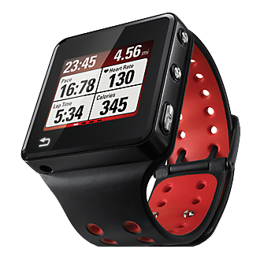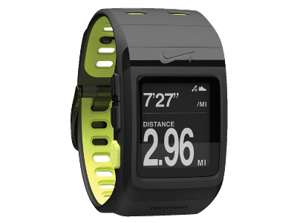

**Figure 1: MotoACTV and Nike+ GPS SportsWatch**

Although the current methods described above produce rich content for the user, there are some areas that leaves the user striving for more. For instance, challenging other users is limited to only the set of users who happen to use the same device. There is no cross-platform challenge. Also, device cost is a big drawback and android/iOS integration with wireless HRM is very limited at this point.

There are clear benefits for mobile implementation (direct pairing) with HRM. For one, it frees users from having to connect to a PC to upload workout data since mobile applications utilize the smart-phone cellular or wi-fi networks to initiate the sync process. The main benefit to the user, however, is that it eliminates the need for users to acquire expensive hardware to record their workout data. Typical costs are shown in table 1.

|  |  |  |
| --- | --- | --- |
| Device | Manufacturer | Price Range |
| MotoACTV 8GB | Motorola | ~$150 |
| Nike+ GPS SportsWatch and Nike+ Sensor | Nike | $169 + $29.99 = ~$200 |
| Wireless HRM | Various (Motorola, Garmin, Polar) | ~$50 - $70 |
| iMapMyRun | MapMyFitness - iOS | Free |
| Encomodo Sports Tracker | Encomodo – Android | Free |

**Table 1: Fitness & Health Monitoring Devices / Apps Landscape**

A mobile application for fitness enhancement via HRM pairing requires 1 piece of HW. That is, 75% lower cost based on values listed in table 1.

**What are heart rate zones?**

Heart Rate is the number of heart beats per minute (bpm). Heart rate varies depending on your activity, from vigorous exercise to sleep. If you know and monitor your heart rate, you get maximum efficiency from your workouts. Maximum safe heart rates vary greatly in people based on age and gender and there are many formulas and tables available to calculate what those rates might be. Generally, zones 1-5 represent 50-59%, 60-70%, 71-79%, 80-90% and 91-100% of the target Max heart rate. For example, the data shown below represent the heart rate for a 25 year old male according to the equation:

Max HR = 220 – Age → 220 – 25 = 195:

**Figure 2: Heart Rate Zones for 25 year old Male**

The concept behind the HR zones is to classify various stages of physical activity. The key differentiator between the HR zones is where the energy (calories burned) utilized by the body is coming from.

|  |  |  |
| --- | --- | --- |
| HR Zone | % of Max HR | Description |
| 1 | 50-59 | Warm-up zone, healthy HR (calories burned 85% from fat) |
| 2 | 60-70 | Fitness zone, optimal fat burning (calories burned 85% from fat) |
| 3 | 71-79 | Aerobic zone, endurance training (calories burned 50% from fat) |
| 4 | 80-90 | Anaerobic, performance training (calories burned 15% from fat) |
| 5 | 91-100 | Maximal effort, “red-line” |

**Table 2: HR Zones**

**Why do heart rate zones matter?**

The biggest reason why this matters is because a person can tailor his or her training based on HR zones in order to achieve a particular benefit from working out such as: increased endurance, fitness, maximum sprint pace, performance capacity. It will also allow him or her to ensure that he or she is working out at a proper intensity level. Often when people just go by their ‘feel’, they may not be challenging their body as much as they could be. Knowing your real-time HR can be an indicator to increase intensity. The table shown below illustrates this concept

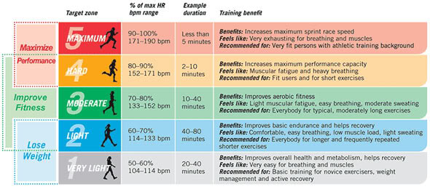

**Figure 3: Benefits of Heart Rate Zone Training**

 If your goal is to burn fat as a fuel source during your workout session, you’ll want to be working out at a lower overall heart rate because for your body to burn fat (optimally), you must be doing lower intensity exercise (since fat takes longer to break-down so the fuel will be delivered at a slower rate). The desired zones for this type of exercises are Zones 1 and 2. The energy system at play for low intense exercise is much different for high intensity exercise, so depending on your overall workout goals, you can adjust your heart rate to match.

If you’re aiming to boost your fitness level on the other hand, then you’ll want to be working out at a much higher heart rate, often at a percentage of your maximum heart rate such as 80-90%, which corresponds with Zone 4. It would be very difficult to tell if you’re reaching these intensities without a heart rate monitor.

**How can a heart rate monitor improve your workout performance?**

Heart rate monitoring is a widely used training method by athletes of all levels. The very reason why even use a heart rate monitor is to help improve performance by ensuring that the user is working out at a sufficient intensity level to derive proper benefits. The simple answer is that HRM gives users a tool to record, measure and track performance. For example, a MotoACTV device equipped with a heart rate monitor records 1 sample per second. Below is an example of the data recorded for a ~43 minute bike workout (heart rate and elevation data is displayed):

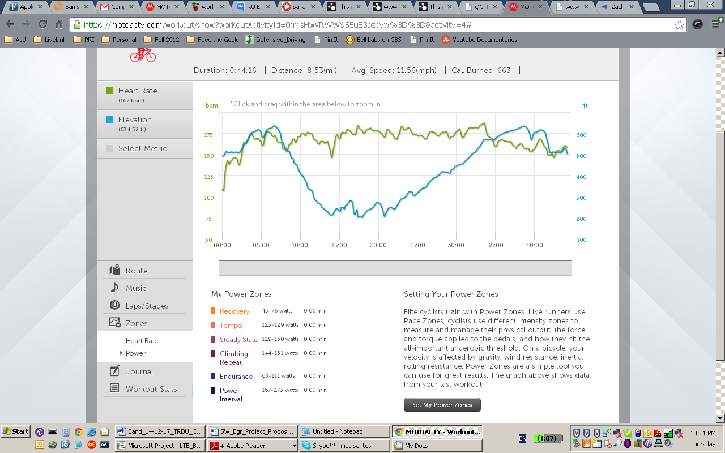

**Figure 4: Real data for a 43 minute workout with MotoACTV**

Contrasting the workout data collected with a HRM over time should clearly show if more time is spent in Zones 4 and 5 during a workout.

The second reason why using a heart rate monitor is beneficial in increasing running or cycling performance is because it will provide a very good way to increase lactic acid threshold. Since a user is able to engage in more intense workouts over time by monitoring the heart rate data collected and adjusting their workout accordingly, a long term consequence is increased the lactic acid threshold by your body.

**1.3 Project Overview**

To fulfill the user requirements for the problem statement, Workout with Friends provides multiple platforms (web-based and mobile based) that allow users to challenge friends or themselves based on key biometric data. The service provided to the end user is reliable in determining a workout intensity score in addition to being accessible with ease by a large audience. Workout with Friends strives to address key limiting factors that drive most people to halt their workout activities: lack of motivation. By providing a user-friendly gaming platform, Workout with Friends entices friendly competition in order to motivate users to workout.

The basic requirement for any user to be able to play Workout with Friends is that biometric data must be recorded with a heart rate monitor for the duration of the proposed workout. Any user equipped with a HRM should be able to play Workout with Friends regardless of the device used to collect the required key biometric data (calories burned and heart rate zones). Workout with Friends’ mobile platform for Android will address user’s concern over cost meanwhile Workout with Friends’ Facebook Web platform will address user’s accessibility concerns. For example: a user with a Nike+ GPS SportsWatch paired with a HRM should be able to challenge a user equipped with a MotoACTV paired with a HRM or a user simply equipped with a smart phone paired with a HRM.

As a secondary goal, Workout with Friends strives to make the workout experience a more enjoyable one by the end user through an engaging user interface that marries gaming with social aspects. To this end, communication with a user’s friend is central to the design. By delivering Workout with Friends as an embedded Facebook App, users are easily able to login from a central location and challenge friends in the user’s Facebook friend list in a straightforward fashion. Additionally, to create a compelling and engaging user experience, Workout with Friends introduces the ability for users share the outcome of the challenge on the user’s Facebook wall. This is perhaps the most exciting feature that Workout with Friends introduces, which is ahead of the competition. The ability to post user stories on their friends or opponents Facebook wall adds an additional dimension to the competitiveness nature of the game through bragging rights.

**1.4 Glossary of Key Terms**

**Resting Heart Rate** – The heart rate, measured in beats per minute (bpm), measured when the subject is awake, but has not performed physical activity/ exerted themselves recently. The resting heart rate is an indicator of general health.

**Max Heart Rate** – The highest rate of heart beats per minute that is achieved during exercise with 100% exertion. Percentages of this rate are used to indicate exercise intensity.

**Heart Rate Training** – Monitoring heart rate data through the use of a measuring device and adjusting one’s exercise accordingly to achieve specific fitness goals.

**Hear Rate Zones** – 5 ranges which are grouped as a percentage of maximum heart rate. Each zone has varying benefits to exercising within that heart rate zone, and a user can choose to exercise within a particular zone, based on their exercise goals.

**Lactic Acid Threshold** – Under normal exercise, the production and removal of blood lactate is equal. At this threshold of exercise intensity, there is an abrupt increase in the production of blood lactate

**Player / User** – A participant of the Workout with Friends application.

**Challenge** – A competitive workout between either two players or a player’s own history. A winner is determined through a score comparison based on points assessed based on calories burned and time spent in heart zones (with highest weight placed in zone 4 and 5).

**Device** - The heart rate monitor used to collect heart rate data during exercise, and upload the results to the Workout with Friends application.

**Administrator** – The manager who has access to maintenance of the Workout with Friends system

**Database** – The storage of all relevant Workout with Friends data, including player profiles (name, age, gender, weight), player heart rate data and calories burned.

# 2. System Requirements

**2.1 Requirements Summary**

To fulfill the user requirements for the problem statement, Workout with Friends provides multiple platforms (web-based and mobile based) that allow users to challenge friends or themselves based on key biometric data. The service provided to the end user must be reliable in determining a workout intensity score in addition to being accessible with ease by a large audience. Workout with Friends strives to address key limiting factors that drive most people to halt their workout activities: lack of motivation. By providing a user-friendly gaming platform, Workout with Friends entices friendly competition in order to motivate users to workout.

The basic requirement for any user to be able to play Workout with Friends is that biometric data must be recorded with a heart rate monitor for the duration of the challenge. Any user equipped with a HRM should be able to play Workout with Friends regardless of the device used to collect the required key biometric data (calories burned and heart rate zones).

Workout with Friends’ mobile platform for Android will address customer’s concern over cost meanwhile Workout with Friends’ Facebook Web platform will address customer’s accessibility concerns. For example: a user with a Nike+ GPS SportsWatch paired with a HRM should be able to challenge a user equipped with a MotoACTV paired with a HRM or a user simply equipped with a smart phone paired with a HRM.

As a secondary goal, Workout with Friends strives to make the workout experience a more enjoyable one by the end user through an engaging user interface that marries gaming with social aspects. To this end, communication with a user’s friend is central to the design. By delivering Workout with Friends as an embedded Facebook App, users are easily able to login from a central location and challenge friends in the user’s Facebook friend list in a straightforward fashion. Additionally, to create a compelling and engaging user experience, Workout with Friends introduces the ability for users share the outcome of the challenge on the user’s Facebook wall. This is perhaps the most exciting feature that Workout with Friends introduces, which is ahead of the competition. The ability to post user stories on their friends or opponents Facebook wall adds an additional dimension to the competitiveness nature of the game through bragging rights.

**2.2 Function Requirements Table**

|  |  |  |
| --- | --- | --- |
| ID | Priority Weight | **Requirement** |
| REQ-1 | 5 | The system shall be able to keep a database for all user data. |
| REQ-2 | 5 | The system shall calculate a workout intensity score that correlates to a workout data set consisting of HR data and calories burned. |
| REQ-3 | 5 | The system shall be able to execute a comparison between two workout intensity scores to determine a winner. |
| REQ-4 | 4 | The system shall be able to allow users to send a challenge request against one or more registered users. |
| REQ-5 | 4 | The system shall allow user to accept a challenge from another registered user. |
| REQ-6 | 4 | The system shall allow user to refuse a challenge from another registered user. |
| REQ-7 | 3 | The system shall allow users to designate the length of a challenge as it relates to the workout length that user is challening the opponent in real life. |
| REQ-8 | 5 | For the web platform, the user shall be allowed to enter workout data to complete a challenge |
| REQ-9 | 5 | For the mobile platform, the system shall be able to establish wireless connectivity with a heart rate monitor prior to start of a challenge |
| REQ-10 | 5 | For the mobile platform, the system shall display the user's real-time HR at the top of notification bar while the application runs in the background for the duration of the challenge. |
| REQ-11 | 5 | For the mobile platform, the system shall allow the user to either manually trigger or establish a “warm up” timer to start collecting data |
| REQ-12 | 5 | For the mobile platform, the system shall collect data from the wireless heart rate monitor and store it locally in the smart phone. Only once a workout is completed the system shall synchronize the data with a database automatically |
| REQ-13 | 3 | The system shall allow users to be able to view his or her’s overall record against previous opponents. |
| REQ-14 | 2 | The system should allow users to communicate with oponents via in-challenge messaging. |
| REQ-15 | 2 | The system should allow the user to register an account with their Facebook profile and enter personal information. |
| REQ-16 | 1 | The system should allow the users to post the outcome of a challenge on his Facebook wall as well as the opponents Facebook wall (if permission is granted) |
| REQ-17 | 1 | The system should allow users to search for a friend (opponent) via his facebook friend’s list or user name. |
| REQ-18 | 1 | The system should allow the users to send an invite an unregistered friend. |
| REQ-19 | 1 | The system should allow users to be able to set up a challange against a random opponent with similar ranking. |
| REQ-20 | 1 | The administrator should be able to access user account data. |
| REQ-21 | 1 | The administrator should be able to retire a user’s account. |

**2.3 Non-Functional Requirements Table**

| Non-Function Requirements | | |
| --- | --- | --- |
| ID | Priority Weight | **Requirement** |
| REQ-21 | 5 | All user data shall be stored in the system’s database. No user information should be stored on the user’s device. Users shall not be able to directly modify any data. There must be two copies of every record in case of system failure. |
| REQ-22 | 5 | Users shall not be able to access the user accounts of other users. Users shall not be able to access administrator accounts. |
| REQ-23 | 3 | The system should require minimum maintenance, and of at most once per week. |
| REQ-24 | 3 | The system should be able to maintain function in the event of any changes to Facebook’s API. |
| REQ-25 | 2 | The system shall be simple and easy to use. Data should be presented to the user in such a way that the user’s focus is automatically drawn to it when the users view the page. |
| REQ-26 | 2 | The system content should be centered in the center of the page. The user should not need to scroll down to view the data or access the majority of the options on the page. |
| REQ-27 | 2 | The user must be able to set up a challenge in 2 clicks or less. |
| REQ – 28 | 2 | During registration the system should provide the user with instructions on how to play. It should also give the users the ability to skip the introduction and return to it at a later time |

**2.3 On-Screen Appearance Requirements**

Because of the intention to integrate the game with Facebook as an app, the application must adhere to all policies as outlined on Facebook’s Policy Section – Features and Functionality, found at <https://developers.facebook.com/policy?_fb_noscript=1>. As it relates to Facebook integration, there shall be an explicit “Log Out” button for both the application and Facebook (6). There shall be no Facebook icons nor shall there be any Facebook derivative icons (8). Any non-Facebook content displayed by the application shall explicitly state that it is not Facebook content. The applications shall not obscure any Facebook elements. Although the implementation may use pop-ups to alert the user to new messages, these messages shall not obscure and Facebook-required functionalities.

Having said that, the following are the major On-Screen Requirements:

**1. Landing page:** on Facebook Market App. When users search for apps, the results takes to landing page. Landing page gives users the option to look at game description, info, screen shots, supportability, permissions, profile and cover pictures. It gives user the option to play the game via an embedded app or send to mobile.

**2.e – Login** with Facebook account: takes users to registration page, sets up single-sign-in services from facebook to take users automatically to home screen next time.

**2.d – Registration:** for new and 1st time users (some info should also be available in About Screen)

**2.d.1** - part 1 - game description and how-to-play

**2.d.2** - part 2 - disclaimers & permissions

**2.d.3** - part 3 - user info (name, user name, gender, age, resting heart rate, weight, sports preferences, share stores (y/n), share location (y/n), alerts..)

**2.a - Home Screen** major building blocks:

1) high level status bar: (number of challenges: completed, waiting for opponent, won; weekly points, delta of wk-to-wk) - button takes users to "Performance Tracker screen" (2.j)

2) About

3) Start a new challenge

4) Open challenges

5) Challenge History

6) Help

**2.b - Start a new challenge screen**

**2.b.1** - Search for facebook friends, random local opponent, search by username, select previous workout (self-trainer mode)

**2.b.2** - (from select facebook friends) - populates list of FB friends, allow to select 1 or more opponents

**2.b.3** - Pre-challenge screen: shows selected friends, asks users to input: challenge nickname, workout duration, options (web or mobile), message opponents

**2.h - Game Screen**

**2.h.1** - Web Game Screen - Directions: please make sure to wear a HRM device to capture calories, HR and HR zone data. Empty spaces for user to input these 3 required fields

**2.h.2.1** - Mobile Game Screen - Directions: connect HRM (wireless), warmup options (timer, or start data collection when HR passes warmup threshold (40% of max target HR)), and manual start. Program goes to background once data collection is initiated, displayed in top android notification bar: instant HR, time elapsed, time remaining, 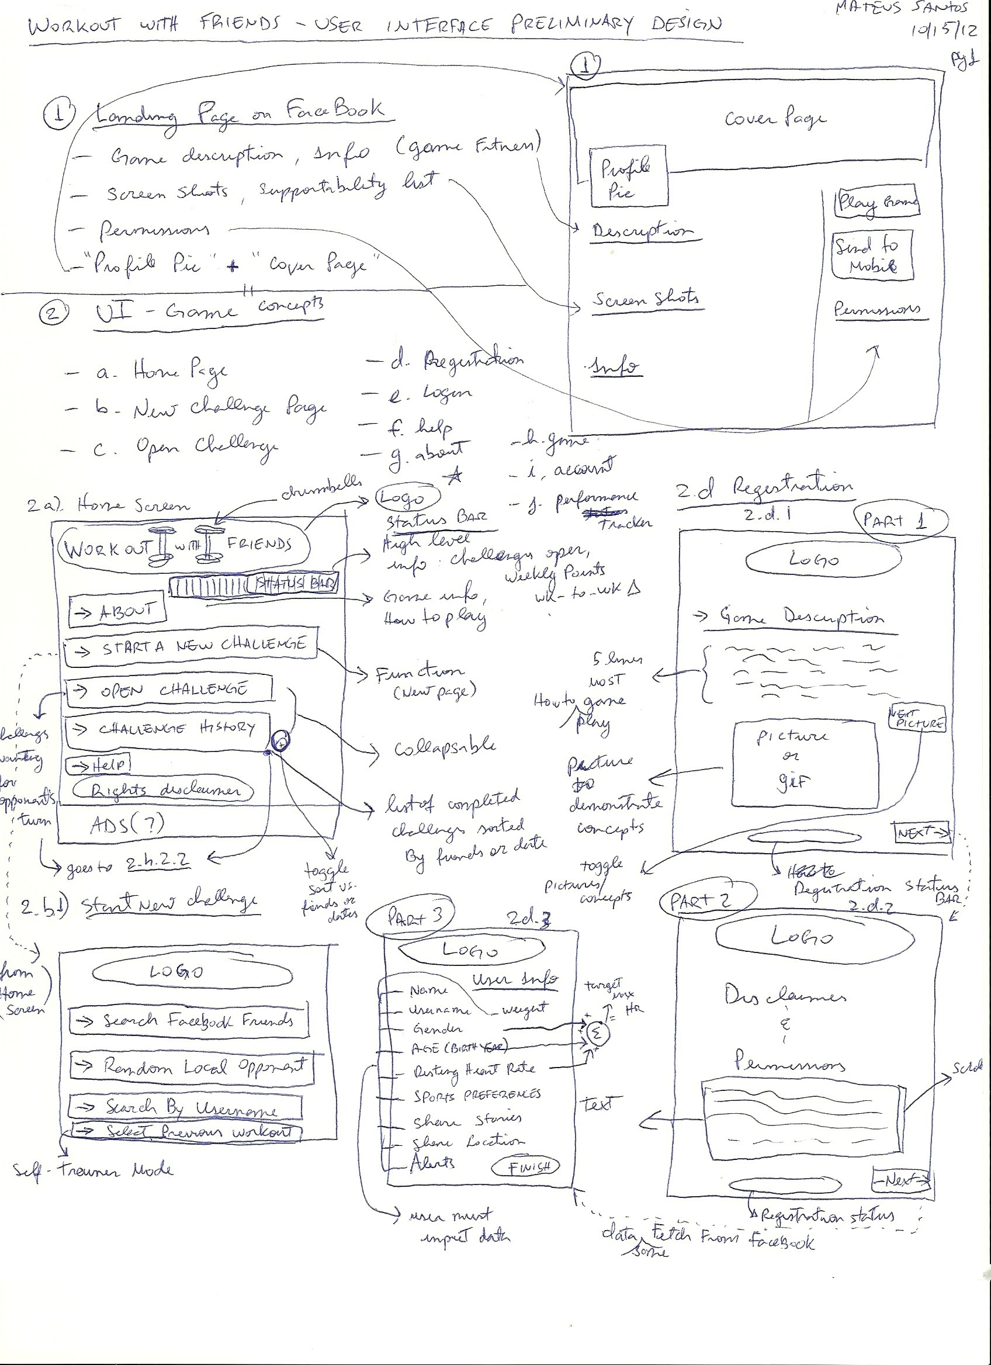

**2.h.2.2** - Game Results screen - from 2.h.1 and 2.h.2.1, shows calculated points for calories, HRZ 5, HRZ 4. (opponent results may not be known yet). clicking "next" uploads data to database

**2.c - Open Challenge:** function residing in Home Screen, lists open challenges waiting for opponents turn

**2.f – Help**: FAQ's, report user, send feedback to dev team, upgrade SW.

**2.g – About:**  users can find more info (links) on HR, training and tips. Users can also access how-to-play and game description available at registration, Help (takes users to help screen) and Account (takes users to Account Management screen)

**2.i** – **Account**: users can review and/or edit account attributes such as: nickname, weight, resting HR, alerts, sharing options, age

**2.j** - **Performance tracker**: shows numerical values for challenges completed, winning %, margin won/lost, calories counter (toggle monthly vs weekly vs all-time view). Also users may select to graph such attributes

The following sketches illustrates these concepts.

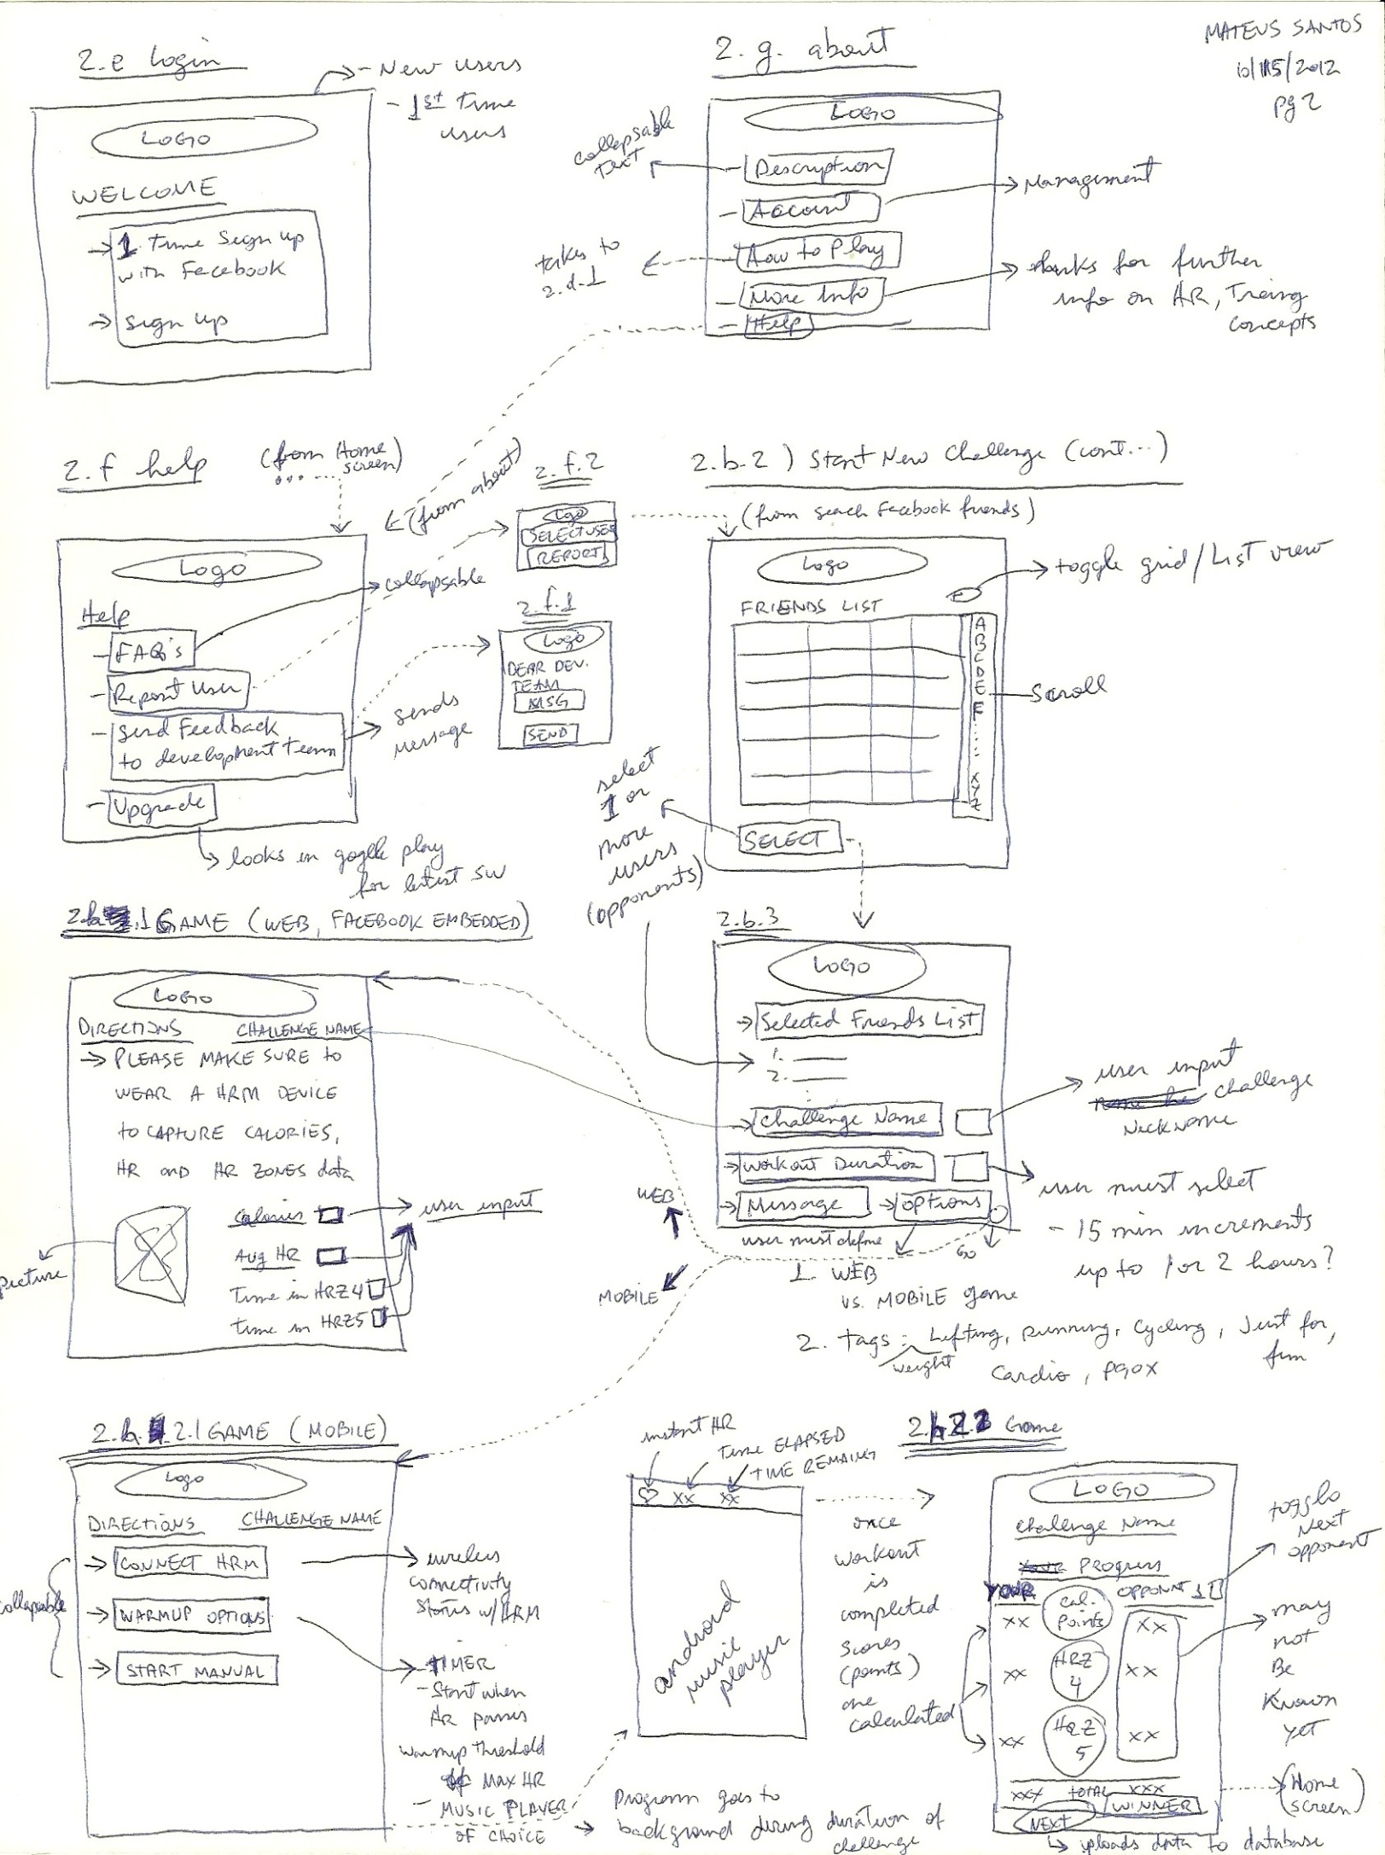

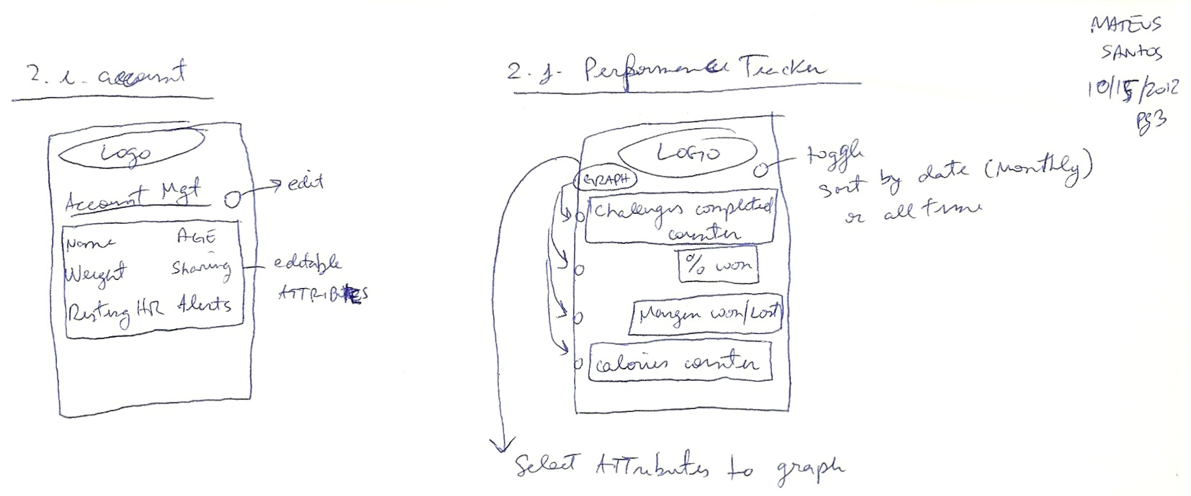

**2.4 Acceptance Tests**

In order to confirm the implementation of the major requirements listed in sections 2.1 and 2.2 the following acceptance tests need to be met.

1. A user can register a new account with the system.
2. A user can log in so that he/she can gain access to his/her personal account.
3. An administrator can log in so that he can gain access to his and all user accounts.
4. A user can log out so that he/she can restrict access to his/her personal account from that computer session.
5. An administrator can log out so that he/she can restrict access to his/her administrator account during that computer session.
6. A user can deregister so that he/she can no longer access the account.
7. An administrator can deregister an account so that the user associated with the account can no longer gain access.
8. A user can find a user profile by via entering username or real name so that he/she can gain access to the user’s public profile.
9. A user can match himself/herself via game type so that he/she can initiate a challenge.
10. A user can enter workout statistics into the interface to complete a challenge.
11. A user can enter workout statistics into the interface to track statistics.
12. A user can request a historical view so that he/she can track workouts for a given range of dates.
13. A user can display a graphical representation of workout statistics so that he/she can track workouts.
14. A user can set a workout goal so that he/she can initiate a game.
15. A user can get a workout goal so that he/she can see a previously set goal.
16. A user can set a long term performance goal so that he/she can track long term performance.
17. A user can get a long term performance goal so that he/she can see the performance previously set.
18. A user can compare goals with another user so that he/she can track the other user’s progress for comparison.
19. A user can get a score so that the workout statistics are more easily understandable.
20. A user can upload a message to another user so that he/she can correspond with another user.
21. A user can download messages that have been uploaded by other user so that he/she can correspond with another user.
22. A user can get a local rank so that he/she can compare his/her overall score to all of his/her friends.
23. A user can get a global rank so that he/she can compare himself/herself to all other users.
24. A user can challenge another user so that he/she can initiate a game.
25. A user can accept another user’s challenge so that he/she can initiate a game.
26. A user can add friends to his/her friend list so that he/she can foster social aspects of the game.
27. A user can delete a friend so that he/she can no longer see the other user on his/her friend list.
28. A user can accept a friend so that the two will both appear on the other’s friend list.

**2.5 Acknowledgements**

At this stage of development the expected initial implementation is a Facebook embedded app for web based applications. The game will function as an app existing within the Facebook environment. Players will register their facebook account with the system in order to play the game and will enter workout data to complete a challenge and/or track workout statistics.

Future development will expand the functionalities supported (including wireless connectivity to a HRM) in addition to platform supportability to mobile android smart phones.

Thus, currently we have not yet analyzed the use case descriptions for the mobile implementation. We do not expect for the system to meet all customer requirements until final implementation. Additionally, acceptance testing and new concepts may need to be formulated at a later time.

# 3. Functional Requirements Specification

**3.1 Stakeholders**

There are several primary end-users for fitness based social gaming. First, there are the fitness oriented individuals (and their partners) who exercise daily and who may use heart rate training to achieve their personal goals. This category includes athletes of all levels and people who are just old enough to use their local weight-lifting gym and treadmills, but also kids and adults of many ages. The secondary set of end-users are the people who aim to lose weight through exercising or who will use social gaming to stay motivated to achieve their workout goals. Given the low upfront cost to use and play the game.

Other possible proponents of this game may also include fitness experts, coaches and local gyms that may be use the game as a tool to teach healthy training principles via HR monitoring.

As the game matures, further specialization can be tailored to certain sports type such as: marathon (running), cycling and weight-lifting; in order to address certain groups of fitness

**3.2 Actors and Goals**

1. Player - a registered user of the software;
2. Opponent - a special case of Play actor, defined relative to the Player who initiated the given use case; this actor can do everything as Player, however, it should be distinguished from the initiating Player to be able to describe the sequence of interactions in use case scenarios;
3. Visitor - an unregistered user;
4. Database - records of all the Player’ s performance;
5. Facebook - provider for all social information of Players and Visitors;
6. Administrator - a special user of the software who have top priority access to the software database

**3.3 Use Case Descriptions**

**UC-1: MonitorExercise**- Allows the Player to get the self monitoring data analyzed.

Derived from REQ-1a, REQ-1b.

**UC-2: ChallengeFriend**- Allows the Player to challenge an Opponent to play a

competition based on their analyzed monitoring data. Derived from REQ-4.

**Initiating Actor:** Player

**Actor’s Goal:** To create a new game with a friend

**Participating Actors**: Challenged Player, Database

**UC-3: ChallengeSelf**- Allows the Player to challenge his previous workout performance.

**UC-4: ViewRecord**- Allow the Player to view the ranking of his/ her result against other local users. Derived from REQ-11.

**UC-5: SendMessage**- Allow the Player to send a message to the Opponent while a challenge session is open. Derived from REQ-12.

**UC-6: Register**- Allow a Visitor to register an account for the software with his/ her

Facebook profile.

Derived from REQ-13.

**Initiating Actor:** Player

**Actor’s Goal:** To create an account

**Participating Actors:** Database, Facebook

**Precondition:** The system must support account creation.

**Postcondition:** A new account is in created for the user. This account will store player information and game history.

**Flow of Events for Main Success Scenario:**

1 → The player navigates to the application Facebook’s website and clicks

“Get App”

2 ← Facebook displays page asking if the player will allow the app to access

information.

3 → The user clicks “Allow”.

4 ← Facebook authenticates the user.

5 ← The system signals to the database to create a new account with the

above information.

6 ← The database creates the user account and signals to the system that

the account was created.

7 ← The system signals to the user that an account has been created.

8 → The user proceeds to registration screen (2.d.1)

**UC-7: PostReult**- Allow a Player to post the result of a challenge on his Facebook wall as well as the Opponent’ s Facebook wall.

Derived from REQ-14.

**UC-8: SearchFriend**- Allow a Player search for a friend in the registered users.

Derived from REQ-15.

**UC-9**: **InviteFriend**- Allow a Player to send an invitation to an unregistered friend on Facebook.

Derived from REQ-16.

**UC-10: ChallengeRandom**- Allow a Player to challenge a random Opponent with a similar ranking from the registered users. Derived from REQ-17.

**UC-11: AccessUserAccount**- Allow Administrator to access a registered user’ s account. Derived from REQ-18.

**UC-12: DeleteUserAccount** – Allow Administrator to de-register a user and delete the user’ s account. Derived from REQ-19.

**3.3.2 User Case Diagrams**

The use case diagram is shown in Figure 3-1. Player, Opponent, Visitor and Administrator <<initiate>> all use cases, except for UC-2 (ChallengeFriend), UC-3 (ChallengeOneself) and UC-10 (ChallengeRandom), which are <<extend>> from UC-1 (MonitorExercise) as sub-use-cases. Database and Facebook store monitoring data and social relation data for Player, Opponent and Visitor, so they are <<participate>> in all use cases. Opponent is generated from a Player when the Player chose to run UC-2 (ChallengeFriend).

**3.3.4 Traceability Matrix**

Use cases are designed to meet the system requirements, the traceability matrix in Table 3-1 shows the mapping relation between system requirements and use cases of this software.



**Figure 3-1:**  **Use Case Diagram**

|  |  |  |  |  |  |  |  |  |  |  |  |  |  |  |  |  |  |  |  |  |
| --- | --- | --- | --- | --- | --- | --- | --- | --- | --- | --- | --- | --- | --- | --- | --- | --- | --- | --- | --- | --- |
| REQ # | 1 | 2 | 3 | 4 | 5 | 6 | 7 | 8 | 9 | 10 | 11 | 12 | 13 | 14 | 15 | 16 | 17 | 18 | 19 | 20 |
| UC1 | x |  |  |  |  |  |  |  |  |  |  |  |  |  |  |  |  |  |  |  |
| UC2 |  |  |  | x |  |  |  |  |  |  |  |  |  |  |  |  |  |  |  |  |
| UC3 |  |  |  |  |  |  |  |  |  |  |  |  |  |  |  |  |  |  |  |  |
| UC4 |  |  |  |  |  |  |  |  |  |  | x |  |  |  |  |  |  |  |  |  |
| UC5 |  |  |  |  |  |  |  |  |  |  |  | x |  |  |  |  |  |  |  |  |
| UC6 |  |  |  |  |  |  |  |  |  |  |  |  |  |  |  |  |  |  |  |  |
| UC7 |  |  |  |  |  |  |  |  |  |  |  |  |  | x |  |  |  |  |  |  |
| UC8 |  |  |  |  |  |  |  |  |  |  |  |  |  |  | x |  |  |  |  |  |
| UC9 |  |  |  |  |  |  |  |  |  |  |  |  |  |  |  | x |  |  |  |  |
| UC10 |  |  |  |  |  |  |  |  |  |  |  |  |  |  |  |  | x |  |  |  |
| UC11 |  |  |  |  |  |  |  |  |  |  |  |  |  |  |  |  |  | x |  |  |
| UC12 |  |  |  |  |  |  |  |  |  |  |  |  |  |  |  |  |  |  | x |  |

**Table 3-1: Traceability Matrix**

**3.4 System Sequence Diagram**

In this section, the system sequence diagrams of some use cases defined above will be illustrated.

**3.4.1 UC-1: MonitorExercise**



**Figure 3-2: Sequence Diagram of UC-1: MonitorExercise**

**3.4.2 UC-2: ChallengeFriend**



**Figure 3-3: Sequence Diagram of UC-2: ChallengeFriend**

* + 1. **UC-3: ChallengeOneself**



**Figure 3-4: Sequence Diagram of UC-3: ChallengeOneself**

* + 1. **UC-10: ChallengeRandom**



**Figure 3-5: Sequence Diagram of UC-10: ChallengeRandom**

# 4. User Interface Specifications

**4.1 User Interface Preliminary Design**

Here are a sample of screen-shots of the current work in progress:

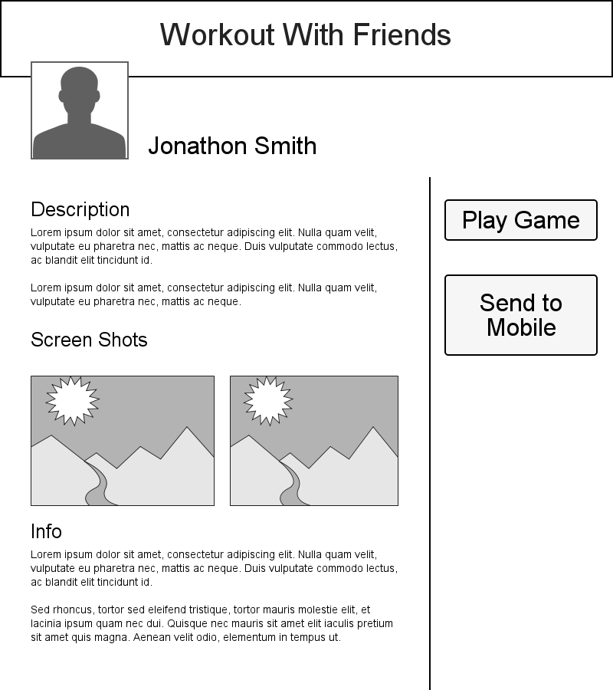

**Facebook App Landing Page Concept (On-Screen Requirement 1)**

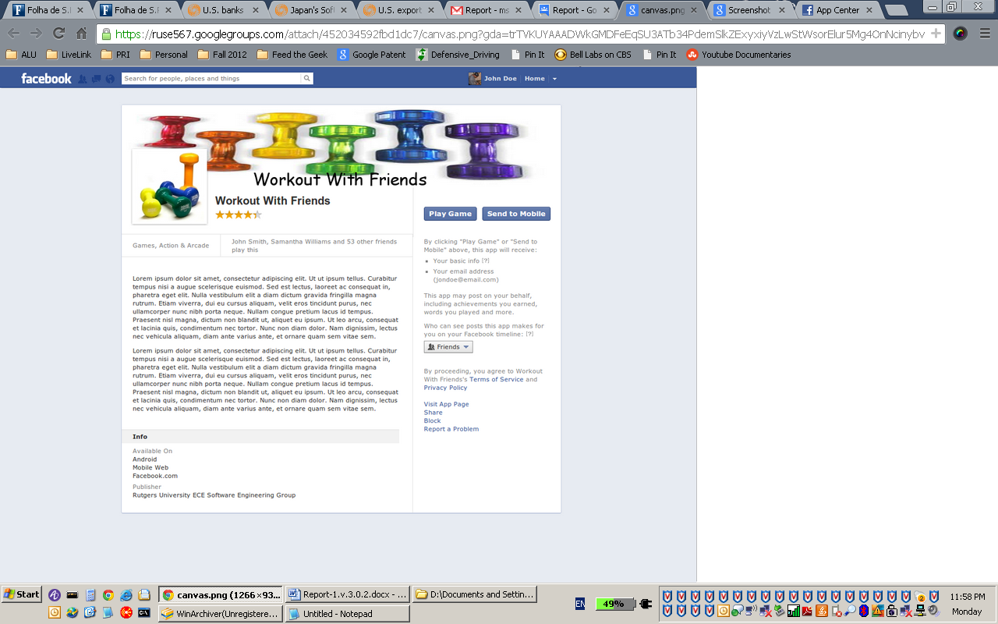

**Facebook App Landing Page (On-Screen Requirement 1)**

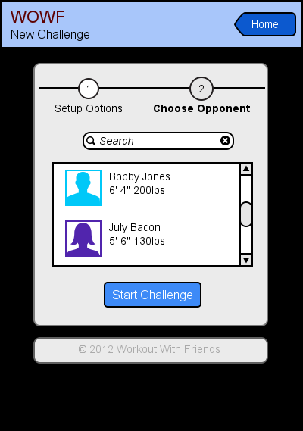

**New Challenge (On Screen Requirement 1)**

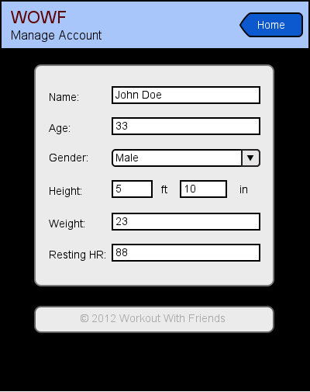

**Account Manage (On Screen Requirement 2.b.2)**

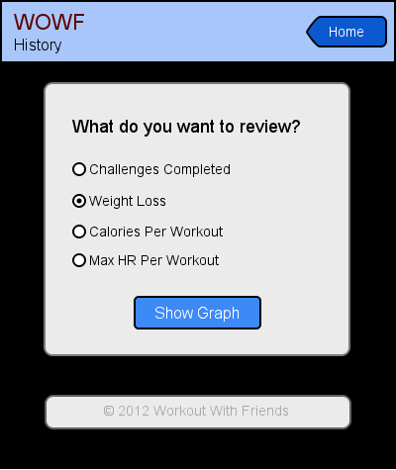

**Challenge History (On-Screen Requirement 2.j)**

**4.2 User Effort Estimation**

Regarding challenge set up, the game takes an estimated 5 minutes to set up from scratch. In total, there are (9) screens from initial login and registration to challenge set up:

Login with facebook account

2) Account Registration Part 1 (Instructions and how to play)

3) Account Registration Part 2 (Disclaimers and Permissions)

4) Account Registration Part 3 (User information)

5) Home Screen

6) Set up Challenge - Search Facebook Friends List

7) Select Friend(s) and send invitation

8) Challenge Setup Screen (options setup)

9) Manual start / timed start (warm-up)

However, once a user is registered subsequent challenge invitations will take substantially less time to set up. In total there are (5) screens once a user is already registered.

1) Home Screen

2) Set up Challenge - Search Facebook Friends List

3) Select Friend(s) and send invitation

4) Challenge Setup Screen (options setup)

5) Manual start / timed start (warm-up)

This does not yet meet the customer requirement of challenge set up in 2 “clicks” (screens) or less

# 5. Domain Analysis

**5.1 Domain Model**

**5.1.1 Concept Definitions**

To analysis the domain model, we first derive domain model concepts and corresponding responsibilities from the formerly defined system use cases. Table 5-1 lists all the domain model concepts and corresponding responsibilities.

|  |  |  |  |
| --- | --- | --- | --- |
| **Responsibility** | **Type** | **Concept** | **Use Case** |
| Load data from HRM | D | MonitoringDataReader | UC-1: monitor exercise |
| Store data into Database | D | MonitoringDataStorer |  |
| . | D | MonitoringDataAnalyser |  |
| Compare analyzed results between Player and its Opponent. | D | FriendChallengeReferee | UC-2: challenge friend |
| Compare analyzed results between Player and his/ her former record. | D | OneselfChallengeReferee | UC-3: challenge oneself |
| Show challenge result. | D | RecordViewer | UC-4: View record |
| Send a message to its Opponent during a challenge. | D | MessageSender | UC-5: send message |
| Allow Visitor to register through a Facebook account. | D | FacebookRegisterInterface | UC-6: register |
| Allow Player/ Opponent post the challenge result on Facebook wall. | D | FacebookPostInterface | UC-7: Post result |
| Allow Player to search for a friend through Facebook. | D | FacebookFriendSearchInterface | UC-8: Search friend |
| Allow Player to invite a friend to join the App through Facebook. | D | FacebookFriendInviteInterface | UC-9: Invite friend |
| Provide a ranked list of all the Player’ s results from Database, as well as the Player’ s ranking in the list. | D | PerformanceRanker | UC-10: Challenge random |
| Allow Player to choose a random Player with certain performance rank to challenge. |  | RandomChallengeSelector |  |
| Compare analyzed results between Player and another random Player with certain performance rank. | D | RandomChallengeRefree |  |
| Allow Administrator to check user account information. | D | UserAccountViewer | UC-11: Access user account |
| Allow Administrator to delete invalid user account. | D | UserAccountOrganizor | UC-12: Delete user account |

**Table 5-1: Domain Concept Definition**

**5.1.2 Association definitions**

Some of the concepts defined above as domain concepts have to work in certain pattern to finish some target, Table 5-2 gives the corresponding association definitions based on the defined domain concepts.

|  |  |  |
| --- | --- | --- |
| **Concept Pair** | **Association Description** | **Association Name** |
| MonitoringDataReader**←→**MonitoringDataStorer | MonitoringDataStorer store down-sampled data read out from MonitoringDataReader to Database. | Data read & save |
| FriendChallengeRefree**←→**MonitoringDataAnalyzer | FriendChallengeRefree give the comparison result based on the output of MonitoringDataAnalyzer. | Analyze and compare |
| OneselfChallengeRefree**←→**MonitoringDataAnalyzer | OneselfChallengeRefree give the comparison result based on the output of MonitoringDataAnalyzer. | Analyze and compare |
| RecordViewer**←→**MonitoringDataAnalyzer | RecordViewer shows the analyzed results got from MonitoringDataAnalyzer. | Show analyzed data |
| PerformanceRanker**←→**RandomChallengeSelector | RandomChallengeSelector allow Player to choose randomly based on the rank list PerformanceRanker gives out. | Choose from analyzed data |
| RandomChallengeRefree**←→**MonitoringDataAnalyzer | RandomChallengeRefree give the comparison result based on the output of MonitoringDataAnalyzer. | Analyze and compare |

**Table 5-2: Association Definition**

**5.1.3 Attribute definitions**

Among the defined concepts, some concepts share the same attribute, and only different from each other as they have different operands. These concepts are listed in Table 5-3.

|  |  |  |
| --- | --- | --- |
| **Concept** | **Attributes** | **Attribute Description** |
| MonitoringDataReader | Data access and storage | Read in and store monitoring data from the device. |
| MonitoringDataStorer |
| MonitoringDataAnalyser | Data analyzer | Analyze data. |
| PerformanceRanker |
| FriendChallengeRefree | Challenge referee | Compare the performance between from different users. |
| OneselfChallengeRefree |
| RandomChallengeRefree |
| RecordViewer | User interface | Store user input to the system, or show analyzed result to user. |
| MessageSender |
| RandomChallengeSelector |
| FacebookRegisterInterface | Facebook interface | Communicate with Facebook database. |
| FacebookPostInterface |
| FacebookFriendSearchInterface |
| FacebookFriendInviteInterface |
| UserAccountViewer | User account interface | Allow Administrator have access and control of the user accounts. |
| UserAccountOrganizor |

**Table 5-3: Attribute Definition**

**5.1.4 Traceability matrix**

|  |  |  |  |  |  |  |  |  |  |  |  |  |  |  |  |  |
| --- | --- | --- | --- | --- | --- | --- | --- | --- | --- | --- | --- | --- | --- | --- | --- | --- |
| **UC** | **Domain Concept** | | | | | | | | | | | | | | | |
| MonitoringDataReader | MonitoringDataStorer | MonitoringDataAnalyser | FriendChallengeRefree | OneselfChallengeRefree | RecordViewer | MessageSender | FacebookRegisterInterface | FacebookPostInterface | FacebookFriendSearchInterface | FacebookFriendInviteInterface | PerformanceRanker | RandomChallengeSelector | RandomChallengeRefree | UserAccountViewer | UserAccountOrganizor |
| UC1 | x | x | x |  |  |  |  |  |  |  |  |  |  |  |  |  |
| UC2 |  |  |  | x |  |  |  |  |  |  |  |  |  |  |  |  |
| UC3 |  |  |  |  | x |  |  |  |  |  |  |  |  |  |  |  |
| UC4 |  |  |  |  |  | x |  |  |  |  |  |  |  |  |  |  |
| UC5 |  |  |  |  |  |  | x |  |  |  |  |  |  |  |  |  |
| UC6 |  |  |  |  |  |  |  | x |  |  |  |  |  |  |  |  |
| UC7 |  |  |  |  |  |  |  |  | x |  |  |  |  |  |  |  |
| UC8 |  |  |  |  |  |  |  |  |  | x |  |  |  |  |  |  |
| UC9 |  |  |  |  |  |  |  |  |  |  | x |  |  |  |  |  |
| UC10 |  |  |  |  |  |  |  |  |  |  |  | x | x | x |  |  |
| UC11 |  |  |  |  |  |  |  |  |  |  |  |  |  |  | x |  |
| UC12 |  |  |  |  |  |  |  |  |  |  |  |  |  |  |  | X |

**Table 5-4: Traceability Matrix**

**5.2 System Operation Contracts**

**MonitorExercise**

Preconditions:

* User has an account
* User has completed a workout

Postconditions:

* The associated challenge is updated accordingly

**ChallengeFriend**

Preconditions:

* User has an account
* Player to be challenged has an account

Postconditions:

* The game is created an made available to both users

**ChallengeOneself**

Preconditions:

* User has an account

Postconditions:

* The game is created an made available to the user

**ViewRecord**

Preconditions:

* User has an account

Postconditions:

None

**SendMessage**Preconditions:

* User has an account
* Player to receive message has an account
* A game has been created between the two players

Postconditions:

* The message is visible to both users

**Register**

Preconditions:

* User has a Facebook account

Postconditions:

* User is stored in the database

**PostResult**

Preconditions:

* A game has been completed between the two users

Postconditions:

NONE

**SearchFriend**

Derived from REQ-15.

Preconditions:

* User has an account

Postconditions:

NONE

**InviteFriend**

Preconditions:

* User has an account
* Invitee has a Facebook account.

Postconditions:

NONE

**ChallengeRandom**

Preconditions:

* User has an account
* Player to be challenged has an account

Postconditions:

* The game is created an made available to both users

**AccessUserAccount**

Derived from REQ-18.

Preconditions:

* Account Administrator is logged in
* Player to be challenged has an account

Postconditions:

NONE

**DeleteUserAccount**

Preconditions:

* Account Administrator is logged in
* Player to be deleted has an account

Postconditions:

* Deleted user data is no longer in the database

**5.3 Mathematical Model**

The following describes the mathematical model as implemented by our database structures.

Let uid be the userid, key be the user password, f be the friends list, u be the user, cl be the challenge list, and c be the challenge



All uids are unique to one user



All emails are unique to one user







A user cannot challenge himself



All users contain one member of each type











A user cannot friend himself



If a user has a friend, that friend must also have the user as a friend



6. Interaction Diagrams

## Sequence Diagrams

In this section, the system sequence diagrams of some most important use cases defined above will be illustrated.

1.1.1 UC-1: MonitorExercise



Figure 1-1: Sequence Diagram of UC-1: MonitorExercise

* + 1. UC-2: ChallengeFriend



Figure 1-2: Sequence Diagram of UC-2: ChallengeFriend

* + 1. UC-3: ChallengeOneself



Figure 1-3: Sequence Diagram of UC-3: ChallengeOneself

* + 1. UC-4: ViewRecord



Figure 1-4: Sequence Diagram of UC-4:View Record

* + 1. UC-5: Send Message



Figure 1-5: Sequence Diagram of UC-5:Send Message

* + 1. UC -6:Register Profile

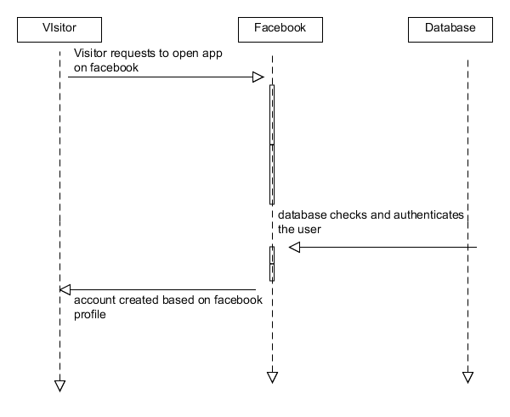

Figure 1-6: Sequence Diagram of UC-6: Register Profile

* + 1. UC-7:Post Result

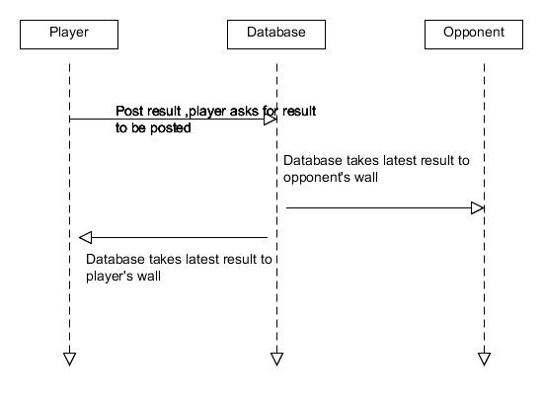

Figure 1-7: Sequence Diagram of UC-7:Post Result

* + 1. UC-8:Search Friend



Figure 1-8: Sequence Diagram of UC-8:Search Friend

* + 1. UC-10: ChallengeRandom



Figure 1-4: Sequence Diagram of UC-10: ChallengeRandom

2. Class Diagrams and Interface Specification

## Class Diagrams

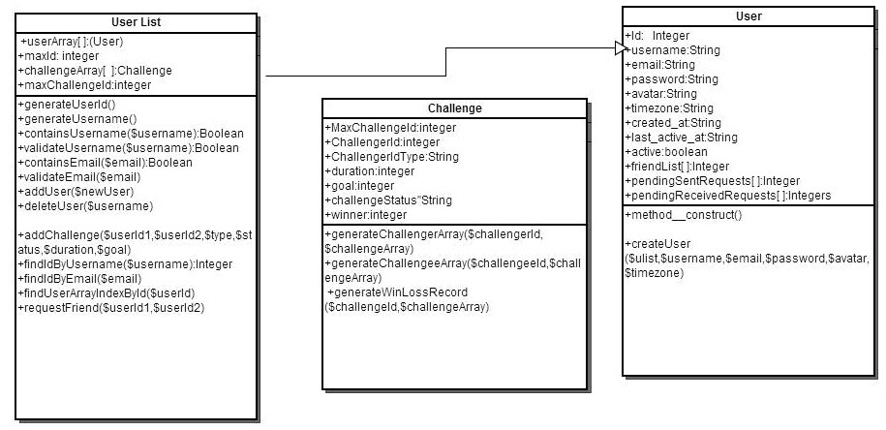

Figure 2-1: Class Diagram

2.1.1 Classes Specifications :

1.Challenge():

The Challenge () class manages the various challenges incorporated by all users .

The variables used in Challenge () and their brief descriptions :

public maxChallengeId:Integer largest challenge id

public challengerId:Integer challenger's id

public type:String The two ways you can play " ("STRENGTH", "ENDURANCE")

public duration: Integer Duration of workout in minutes

*The default value for duration ,if not entered by the user ,is 5 minutes .

public goal:integer Approximate amount of cals.the player wants to burn in calories.

*The default value for goal ,if not entered by the user ,is 5 cals .

public challengeStatus:String ("OPEN","CLOSED")

public winner:Integer User id of winner

Functions in Challenge():

function__construct(maxChallengeId,challengerId,challengeeId,type,status,duration,goal): The explicitly defined constructor which defines all variables to the user’s inputs.

public displayWinner(): A function which prints the id and name of the player who has won .

public generateChallengerArray(challengerId,challengeArray)

return type:array of challenges.

takes the user_list challenge array, and generates all the challenges from an id.

public generateChallengeeArray(challengeeId,challengeArray): for user terminated challenges

return type: array of challenges

function generateWinLossRecord(challengeId,challengeArray)

generates array of integers [W][L][T]

2.User():

The User class gives all details of a user when registering for “workout with friends “.Quite simply , it provides all the details which the user finds when they login and open their dashboard .

The variables used in User() and their brief descriptions :

public id: integer user’s unique user id of exactly 10 digits

public username:String user’s unique username (should start with alpha)

public email:string The email id of user

public password:string should be 8-20 chars ,should include one upper case,one lower case ,one special character and one digit .

public avatar:undefined (string)

public timezone:string

public created_at:string time when the user registered in “workout “ .

public last_active_at:string time when the user last accesses “workout “.

public active:Boolean to check if user is presently active or not .

public friendList[ ]: userid collection of all user ids .

public pendingSentRequests[ ]: userid collection of userids whose requests who have been sent out by the user , but no action has been taken by reciepients .

public pendingReceivedRequests[ ]: userid collection of userids whose requests have not been taken any action by the user .

Functions in User():

method__construct():

Explicitly defined constructor to initialize instance of user, we need to use createUser to add information. This function only initializes arrays-friendslist[],pendingSentRequests[] and pendingRecieved Requests[].

createUser(ulist,username,email,password,avatar,timezone):

createUser() is used to initialize the basic parameters while registering .

$ulist is userlist object.

3.UserList():

The UserList() is a class , quite simply storing the details of “workout with friends” – including the validation functions, and the various operations which can be performed by the user .

The variables used in UserList() and their brief descriptions :

public userArray: (User) array of user objects

public maxId:integer largest issued userid???

public challengeArray: (Challenge) array of challenge objects

public maxChallengeId:integer largest issued challengeid????

Functions in UserList():

Public generateUserId():

This function generates a unique user id when the user registers into the site for the first time .(it works by incrementing the userid by one for every user)

function generateUsername():

The username given by the user is set in this function .

Public containsUsername(String):

return type:boolean

this function checks if username exists in the database of UserArray[ ] in the UserList() class .

Public validateUsername(String ):

return type :Boolean

the function validates and checks if username is of valid type,The username must :contain only alpha numeric characters and start with an alpha character .

public containsEmail(String ):

return type:Boolean

the function checks if emailid exists in the database of UserArray[ ] in the UserList() class .

public validateEmail(String):

return type:Boolean

the function validates and checks if email is of valid type.

Public addUser(User type ):

adds user object to userArray[].

Public deleteUser(String-userName):

this function only deactivates an account , the user can come back and activate it any time later on.

public addChallenge($userId1,$userId2,$type,$status,$duration,$goal):

adds challenge to challengeArray[ ].

function findIdByUsername($username):

This function enables a user to find a friend by searching for the username .The function returns -1 of username doesn't exist, or is not found .

function findIdByEmail($email):

This function enables a user to find a friend by searching for the emailid .

function findUserArrayIndexById(userId):

This function enables a user to find a friend by searching for the userid .

function requestFriend($userId1,$userId2):

This function ,enables a user to invite a friend for a challenge .When the user sends a request to a friend ,the function adds userid2 to userId1's object's pending friend request array[].

## Tractability Matrix

|  |  |  |  |
| --- | --- | --- | --- |
| Use Case | Challenge() | User() | UserList() |
| Compare analyzed results between Player and its Opponent. | × |  |  |
| Compare analyzed results between Player and his/ her former record. |  |  | × |
| Show challenge result. |  | × |  |
| Send a message to its Opponent during a challenge. | × |  |  |
| Allow Visitor to register through a Facebook account. |  | × |  |
| Allow Player/ Opponent post the challenge result on Facebook wall. | × |  |  |
| Allow Player to search for a friend through Facebook. |  |  | × |
| Allow Player to invite a friend to join the App through Facebook. |  |  | × |
| Provide a ranked list of all the Player’ s results from Database, as well as the Player’ s ranking in the list. |  |  | × |
| Allow Player to choose a random Player with certain performance rank to challenge. |  |  | × |
| Compare analyzed results between Player and another random Player with certain performance rank. | × |  |  |

The most difficult thing to do was to trace the actual classes we had obtained to the domain concepts we had recognized earlier and decided to implement :

Concepts implemented in Challenge ():

1. Compare analyzed results between Player and its Opponent.
2. Compare analyzed results between Player and another random Player with certain performance rank.
3. Allow Player/ Opponent post the challenge result on Facebook wall.

The main reason of a challenge class was to for the interaction between the user and any other friend with whom a challenge has been accepted .

The results of a challenge , is given once a challenge is over and a winner is clearly given .

Then , the analysis of the challenge is present , giveingthe user details of who has won , by how much and also the improvement since the beginning .

The option given to the user to post the challenge result on one’s facebook wall could have been given to either the user() class or the challenge() class .However , it iseasy to seethat the result can be posted only once a particular challenge has been completed ,and the results are also present with the challenge() class .Hence , the concept was implemented in the challenge() class .

Concepts implemented in UserList():

Easily the most important class , the user() class helda lot of domain concepts and many were implemented using the UserList() class , as it held all the data of the user ().

1.Compare analyzed results between Player and his/ her former record.

2.Allow Player to search for a friend through Facebook.

3.Allow Player to invite a friend to join the App through Facebook.

4.Provide a ranked list of all the Player’ s results from Database, as well as the Player’ s ranking in the list.

5.Allow Player to choose a random Player with certain performance rank to challenge.

The UserList () has the data of all previous challenges of the user , and can hence show the improvement the user has been making .

3. System Architecture and System Design

## Architectural Stytles

As a web application, our system is based on the Client/ Server model, which benefit the system for centralized data storage, and a scalable amount of users accessing and providing data. The clients of the system are different applications run on different user machines, which allow users to login the system, upload their monitoring data, and complete the data analysis and competition procedure. While on the other hand, the server which runs on a separate machine is in charge of the system database and all the backstage data analyze and process. The server can be further partitioned into several basic functional units, which in charge of data management, data analyze, and user application communication.

By using this client/ server model, the system reduced the procedure done on the client side to a minimum degree, and left all the process work to the server. In this way, we can provide a light user application, also a better coherence with all the user data.

The high degree of centralization also provides great convince for future system updates. We can easily upgrade the system mathematics model for more accurate data analysis, as well as upgrade the database structure for function scaling.

However, the high centralized degree of the system also provide high standard request to the server, as the server act as both the database and the central data processor in the system. This centralized system structure requires high computing capability as well as large storage capability.

## Identifying Subsystems

The system can basically be partitioned into Client subsystem, and Server subsystem. The Client subsystem consists only of a user interface, while the Server subsystem consists of several different functional units. The UML package diagram indicating the workflow between the subsystems can be seen below.

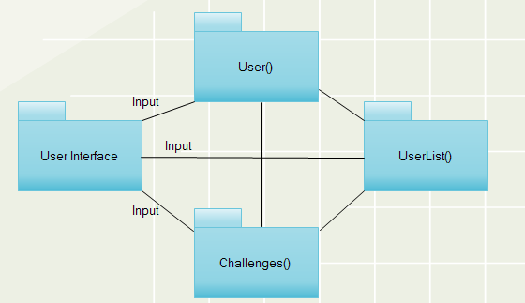

Figure 3-1: UML package diagram

The User Interface is the gateway into the system. It is through this that a user will create his profile, edit said profile, create challenges, view results, and more. The list of users is maintained through the user list package, which is used to create individual user classes. It is also provides the userId information to the challenge package, for match information between two challengers. The user class can be accessed through the user interface to edit a particular user’s personal information as necessary; it can also access the challenge class when creating and maintaining existing challenges. The challenge class is used to create challenges between two users, and must be able to access the initiators information as well as the UserList to inform the challenged user that there is a workout request waiting for them.

## Mapping Subsystems to Hardware

Following the client/ server architecture, the hardware will also be mapped to two sets.

¨ For the Server subsystem, we use a personal PC running as the server (for the current stage).

¨ For the Clients subsystem, the application will be running on different user machine

## Persistent Data Storage

The data stored in the server consist of three main categories: the user information; the user history data; and temporary user data. The temporary user data are the monitoring data that a user uploaded when they start a challenge, and the temporary data would not be stored after the system finish the data analyze.

The user information and the user history otherwise will be stored into the database. The user information kept in the database keeps record of the basic login information for each user, as well as the basic physical characters that will be used for the user’ s challenge. The user history keeps record of all the challenge records of each user, and use for history show and further analysis.

## Network Protocol

Our system has a central server, which is hosted through Apache HTTP. Requests to access information in the databases, which are MySQL, are done through php.

## Global Control Flow

Workout with Friends is an event driven system. This means that users can generate actions in different order. Once a User has created his profile, he can, at any time, challenge another user to a match. The challenged user may accept or decline, and either user can complete the workout at their convenience. Once both users have completed their workout challenge, they can view the results of the particular challenge at any time. In addition, that data can also be observed as part of a broader data.

## Hardware Rerquirement

Workout with Friends requires the use of a MOTO Heart Rate monitor. In addition, the client PC must have an internet connection to be able to access the server.

8. Algorithms and Data Structures

## Algorithms

1. Original Basic Scoring Algorithm

Workout with Friends, is a challenge based application, and the challenge result is based solely on the score of each work out. The workout intensity score is computed based on the weighted score of three different inputs: workout time spent in HRZ 5, HRZ 4, and calories burned.

For the simplistic model:

1. Score1 : Time (in seconds) spent in heart rate zone 5 (90-100% of target max HR) x

factor of 10 (Weighting = 40%)

- Example: 1:45 min = 105 seconds x 10 = 1050

- Score1 = 1050 x 40% = 420 points

2. Score2 : Number of calories burned – (Weighting = 25%)

- Example: 850 calories

- Score2 = 850 x 25% = 212.5 points

3. Score3 : Time (in seconds) spent in heart rate zone 4 (80-89% of target max HR) –

(Weighting = 35%)

- Example: 21:45 min = 1305 seconds

- Score3 = 1305 x 35% = 456.75 points

4. Final Score = Score1 + Score2 + Score3

- Example: Final Score = 420 + 212.5 + 456.75 = 1089.25 points

Based on this model, when calories and HRZ 4 and 5 are known, the calculation is

straightforward and the process to determine a winner is simple.

In the embedded Facebook web-app case, where no specific calories burned and HRZ are known,

we will use a formula to calculate the calories burned. The starting conditions (known variables)

are: gender, weight, age, exercise duration and average heart rate of the workout. The

equations derived by LR Keytel, JH Goedecke, TD Noakes, H Hiiloskorpi, R Laukkanen, L van der

Merwe, and EV Lambert for their study titled "Prediction of energy expenditure from heart rate

monitoring during submaximal exercise” are shown below:

⇒ Male: C = ((-55.0969 + (0.6309 x HR) + (0.1988 x W) + (0.2017 x A))/4.184) x 60 x T

⇒ Female: C = ((-20.4022 + (0.4472 x HR) - (0.1263 x W) + (0.074 x A))/4.184) x 60 x T

Where:

C = Calories burned

HR = Heart rate (in beats/minute)

W = Weight (in kilograms)

A = Age (in years)

T = Exercise duration time (in hours)

However, the simplicity of the model creates some unexpected consequences that needed further consideration.

The group did not believe that this model was sufficiently granular to have an uncontested winner. Although knowing ones heart rate zones during exercise is well documented as being beneficial, to provide a score it showed little or no purpose. Using the maximum heart rate percentage allowed the higher granularity needed to have decisive wins and losses.

Furthermore, having just one game type did not reflect the way that all people work out. Accordingly, two new game types were developed.

1. Improved Scoring Algorithms

Workout with Friends, is a challenge based application, and the challenge result is based not only on the score of the current workout, but on the scores of previous workouts. The following shows the scoring algorithms for each challenge type.

Strength

The strength workouts are based on research of mathematical models that normalize powerlifting abilities based on weight and repetition. The first underlying formula is the Wilks Formula, developed by Robert Wilks, is used for scoring by the International Powerlifting Federation (IPF). The formula to determine the Wilks Coefficient is as follows (from Wikipedia):

\textit{Coeff} = \frac{500}{a + b \cdot x + c \cdot x^2 + d \cdot x^3 + e \cdot x^4 + f \cdot x^5}

x is the body weight of the lifter in kilograms

Coefficients for *men* are:  
a=-216.0475144  
b=16.2606339  
c=-0.002388645  
d=-0.00113732  
e=7.01863E-06  
f=-1.291E-08

Coefficients for *women* are:  
a=594.31747775582  
b=-27.23842536447  
c=0.82112226871  
d=-0.00930733913  
e=0.00004731582  
f=-0.00000009054

The second formula is the Wathan 1 Rep max formula, used to estimate a person’s 1RM based on repetitions at a given weight (from Wikipedia).

1RM = \frac{100 \cdot w}{48.8 + 53.8 \cdot e^{-0.075 \cdot r}}

Where w is weight (dimensions doesn’t matter) and r is reps

The normalized lifted weight is determined as follows:

https://lh3.googleusercontent.com/Wo3KKJga16K-h02XMR_fHD3IGMe1mEhi4bToTenWgr6UY3i3ovLSfxauxMRgB6RSAwBlcHgmkuXeLzIU33qNSMUa3Am0jYKU32i1tWOUn8pC3HoxilhZ

The next challenge that needed to be overcome is how to reward points. One of these challenges is solved by rewarding points in a more granular way. Two other problems that have not yet been discussed will both be solved by mapping the scoring function to an exponential fit: “point grinding” and the plateau effect.

Point Grinding

According to *The Examiner*,

“Grinding is a term from the video game industry which is used to describe the action of repeatedly killing mobs inside of a video game in order to mass gain experience or currency; most of the time the term gets used in relation to grinding for experience.”

The above description is an avid concern when the points are delegated linearly. In the original linear algorithm, work done at ⅕ the effort 5 times will give the same amount of points as doing the work at full effort in the first place. This situation can lead players to gaining points with minimal effort.

Another concern is having players no longer rewarded after reaching a plateau. As defined by livestrong.com,

“When you hear the word "plateau" in the gym, it typically refers to a stop in progress. A plateau can be seen on the scale, such as when you lose a considerable amount of weight, but then the weight loss stops, even if you're still performing the same amount of exercise each week. A plateau can also be in strength and muscle tone, such as not being able to get rid of the last bit of fat on your abs, or not being able to push past a certain weight load while lifting.”

A player may soon become discouraged if he or she can no longer see an increase in score once he or she reaches the plateau. Both the plateau problem and the grinding problem are solved by moving away from a linear fit. The below charts have fitted each game type, strength, speed, and endurance, to an exponential model.

(Bench Press): The x derived in the previous equation is used in the equation in the following chart to determine the score for the challenge:

This equation was designed to score the maximum 1000 points to the person that can perform the maximum bench press rep performed by the record holder, Scot Mendelson, at 715lb.  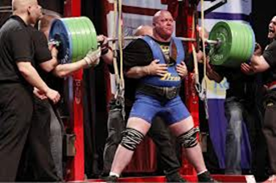

Scot Mendelson, World Record: Benchpress, 715lbs Jonas Rantenen, World Record: Squat, 1265lbs

Using an exponential model allows the challenger to be rewarded even for smaller incremental gains during the plateau period. The following shows the squat equivalent:

(Squat):

(Speed): The following chart shows the exponential algorithm used to determine the points in Speed games. Each line depicts a different distance chosen by the challenger/player. The choices are 100m, 200m, 400m, 800m, and 1600m.

 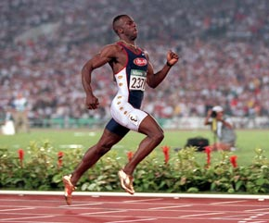

Usain Bolt, World Record: 100m, 9.58s, Michael Johnson, World Record: 400m, 43:18s

World Record: 200m, 19.19s

 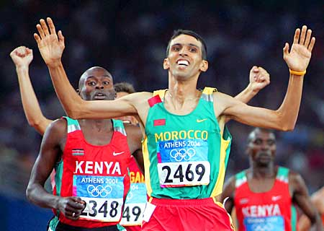

David Rudisha, World Record: 800m,1:41.09 Hicham El Guerrouj, World Record: 1 mile, 3:43:13

These graphs are based on current world best times in these events, and getting these scores would yield the full 1000 points. The x-axis is how many times greater that player’s distance is off from the world best in that event, or User_Time/World_Record_Time. This scheme rewards those players who do comparatively worse on a longer distance event than the short distance counterparts, because the difference between average and elite in short distance and long distance is not linear.

(Endurance): The endurance challenge mathematical model is arguably the most complicated, as there is no real metric to which we can give the title “world best”. As such, this model calls a 100% heart rate “perfect” and calls the calories burned at 100% heart rate “perfect.” Thus, it is more likely that the scores in these challenges will be lower in practice. Below shows the charts depicting the point allocation of both heart rate and calories, and their points are added together to give the overall score.

Again, the challenger has a finite amount of options to choose from: 10minutes,30,45,60, and 120. As with the Speed challenges, it was deemed unfair to reward people more for being able to keep a higher heart rate on shorter events, and the model was adjusted accordingly, by making it exponential.

What makes this model more complicated is the method used to determine average heart rate. In the previous model, points were divvied based on how long one was in a particular zone. This method was open to cheating, where people can essentially play for any length of time and win without having to push himself or herself. The new method takes the maximum moving average for a period the length of the challenge chosen. This method would require the user to push himself for the entire duration of the challenge, as working out longer will more likely result in lower moving averages and not higher ones.

## Data Structures

The server of Work out with friends, has two main databases built, one for user login and administration, and the other for store user performances. Both of them are build using MySQL on the server disk.

1. User Login Information store

The login information was stored as table entries in a separate table.

|  |  |  |  |
| --- | --- | --- | --- |
| **DATABASE** | **TABLE** | **Values** | **Description** |
| dbweb | user | Vchar(10) uid | User id used when login. |
|  |  | Vchar(10) key | Password. |
|  |  | Vchar(20) email | Email. |
|  |  | Char(1) gender | M/F |
|  |  | Int(11) age | Age. |
|  |  | Char(1) access | U- user; A- system administrator. |

1. User performance store

The user performance database was built with the following ideas:

- Construct one data for each use; during registration time.

- In each use there’ re tables stores friends info and performance information for challenge.

|  |  |  |  |
| --- | --- | --- | --- |
| **DATABASE** | **TABLE** | **Values** | **Description** |
| Uid(uer id used to login) | friends | Int(11) id | Index number starts from 1. |
|  |  | Vchar(10) uid | User id used when login. |
|  | perfor | Int(11) id | Index number starts from 1. |
|  |  | Double tz4 | Time spent in time zone 4. |
|  |  | Double tz5 | Time spent in time zone 5. |
|  |  | Double eng | Energy consumption of the workout. |
|  |  | Double scoreSum | Total score calculated from the math model. |

The below table reflects the database design with the newly formed challenges.

|  |  |  |  |
| --- | --- | --- | --- |
| **DATABASE** | **TABLE** | **Values** | **Description** |
| Uid(uer id used to login) | friends | Int(11) id | Index number starts from 1. |
|  |  | Vchar(10) uid | User id used when login. |
|  | type | Vchar(10) typeid | Id (strength, endur, speed) |
|  |  | Double subtype | Target number (% of body weight for strength, distance for speed, time for endurance) |
|  |  | Double result | Result (number of reps for strength, time for speed, HR for endurance) |
|  |  | Double result2 | Null for strength, null for speed, caloreis for endurance |
|  |  | Double scoreSum | Total score calculated from the math model. |

9. User Interface Design and Implementation

## User Interface Design

The main concept of user design interface was to provide for an easy , clear picture of what the user can do on the website application .From the beginning , we have kept it clear that the user should be comfortable with the on screen appearance ,the working of the application. Hence forth , we had identified that the main points in keeping up with the user interface design were(given in the first report) :

1. Landing page: on Facebook Market App.

2.e – Login with Facebook account.

2.d – Registration: for new and 1st time users (some info should also be available in About Screen)

2.d.1 - part 1 - game description and how-to-play

2.d.2 - part 2 - disclaimers & permissions

2.d.3 - part 3 - user info (name, user name, gender, age, resting heart rate, weight, sports preferences, share stores (y/n), share location (y/n), alerts..)

2.a - Home Screen major building blocks:

1) high level status bar: (number of challenges: completed, waiting for opponent, won; weekly points, delta of wk-to-wk) - button takes users to "Performance Tracker screen" (2.j)

2) About

3) Start a new challenge

4) Open challenges

5) Challenge History

6) Help

2.b - Start a new challenge screen

2.b.1 - Search for Facebook friends, random local opponent, search by username, select previous workout (self-trainer mode)

2.b.2 - (from select Facebook friends) - populates list of FB friends, allow to select 1 or more opponents

2.b.3 - Pre-challenge screen: shows selected friends, asks users to input: challenge nickname, workout duration, options (web or mobile), message opponents

2.c - Open Challenge: function residing in Home Screen, lists open challenges waiting for opponents turn

2.f – Help: FAQ's, report user, send feedback to dev team, upgrade SW.

2.g – About: users can find more info (links) on HR, training and tips. Users can also access how-to-play and game description available at registration, Help (takes users to help screen) and Account (takes users to Account Management screen)

2.i – Account: users can review and/or edit account attributes such as: nickname, weight, resting HR, alerts, sharing options, age

2.j - Performance tracker: shows numerical values for challenges completed, winning %, margin won/lost, calories counter (toggle monthly vs weekly vs all-time view). Also users may select to graph such attributes

The main editions were made when we actually started implementing the project , and found that some of the requirements were making the project cumbersome , or difficult to implement with . We also found new ideas to implement , that would make the user interface much more easy .

The main thing was to start implementing the website ,before jumping to the facebook application .In the website , we recognized that the most important part of easy user interface was to have a “dashboard” or home screen with all the data the user would require as as soon as they logged in .The Dashboard consists of :

1.Home

2.User details

3.Challenges

4.Help

5.Find Friends

6.Contact us

Below is a brief description of each :

1.Home : the home screen reiterates to the dashboard , where the user can find all details pertaining to his/her use of the application .

2.User Details :

The user details give all details of the user, which had been inputted during the time of registration .These details can be edited at any point of time .

3.Challenges :

The challenges block provides for all the challenges the user has been in yet . It will include the scores ,who has won the challenge ,who has initiated the challenge ,and also which challenges are yet to be completed .

4.Help:

The help button on the dashboard will provide one with basic details on how to edit one’s information , how to send out a challenge ,and how to invite new friends .

5.Find Friends :

The find friends button can help the user access any friend / or any member through their respective email .

The user can send invites to anyone to register in “ workout with friends “ ,and further on we will also make a way to invite friends present in one’s facebook account .

Main Editions in User Interface Implementation:

TO FIND FRIENDS:

At the beginning the idea was to incorporate the idea of Facebook friends , and keep the application within the limitations of Facebook .However ,as we started working on the concept ,we decided that it would be better not to limit the application , and we started working on a website ,which we would later integrate onto a application .

Now , a user can not only add friends from one’s Facebook account , but also add anyone with an email id .

## User Interface Implementation

As a web based application, the user interface is built using PHP/ HTML/JavaScript, and following are some main page from the application.



Figure 5-1: The home page

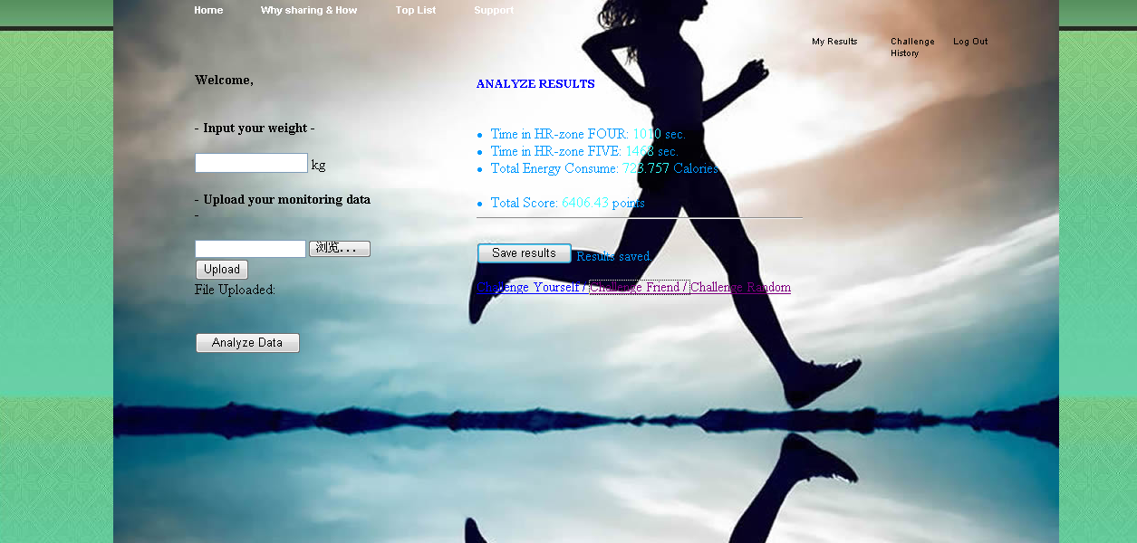

Figure 5-2: The data analyze page

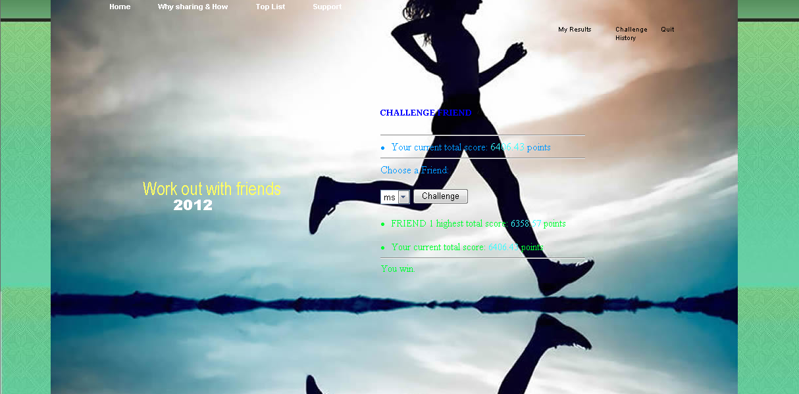

Figure 5-3: The friend challenge page

10. Design of Tests

## System Framework Tests

Goal: To test the basic function of the whole application, the aim is to ensure all the non-critical functions, including user registration, log in, system administration, works smoothly in the system.

Testing approach: Register new users in the system and log in.

Results: All the parts worked well in the system.

## Functional Units Tests

Goal: To test the running condition of all the central parts of the application: the data analysis and challenge parts.

1. Data analysis

Testing approach: Upload a real workout monitor data and analyze the data, save the analysis results.

Results: All the parts worked well in the system.

1. Challenge

Testing approach: Try to upload a different set of workout results through a different user account, analyze the data and start a challenge with the user from last section, and compare the results.

Results: All the parts worked well in the system.

11. Project Management and Plan of Work

## Project Progresses and Plan of Work

|  |  |  |  |  |  |  |  |  |  |  |  |  |
| --- | --- | --- | --- | --- | --- | --- | --- | --- | --- | --- | --- | --- |
| Week  Task |  | 40 | 41 | 42 | 43 | 44 | 45 | 46 | 47 | 48 | 49 | 50 |
| Website Maintenance |  |  |  |  |  |  |  |  |  |  |  |  |
| Web Interface Design |  |  |  |  |  |  |  |  |  |  |  |  |
| Mobile Interface Design |  |  |  |  |  |  |  |  |  |  |  |  |
| Database Structure Design |  |  |  |  |  |  |  |  |  |  |  |  |
| Algorithm Design |  |  |  |  |  |  |  |  |  |  |  |  |
| Algorithm Test |  |  |  |  |  |  |  |  |  |  |  |  |
| Debugging |  |  |  |  |  |  |  |  |  |  |  |  |
| System Test |  |  |  |  |  |  |  |  |  |  |  |  |

From the above table, the group has finish the first step of the project: building a basic functional application. And the following focus would be on improving the further analysis of the data, and developing a mobile interface for the application.

## Contribution Breakdown(Report 2)

|  |  |  |  |  |  |  |
| --- | --- | --- | --- | --- | --- | --- |
| Task | **Mateus** | **Kevin** | **Brien** | **Abdul** | **Daihou** | **Sujana** |
| 1) Interaction Diagrams |  |  |  |  | X | X |
| 2) Class Diagram And Interface Specification |  |  |  |  |  |  |
| a. Class Diagram |  |  |  |  |  | X |
| b. Data Types and Operation Signatures |  |  |  |  |  | X |
| c. Tracebility Matrix |  |  |  |  |  | X |
| 3) System Architecture and System Design |  |  |  |  |  |  |
| a. Architectural Styles |  | X |  |  |  |  |
| b. Identifying Subsystems |  | X |  |  |  |  |
| c. Mapping Systems to Hardware |  | X |  |  |  | X |
| d. Persistance Data storage |  | X |  |  |  | X |
| e. Network Protocol |  | X |  |  |  | X |
| f. Global Control Flow |  | X |  |  |  | X |
| g. Hareware Requirement |  |  |  |  |  |  |
| 4) Algorithms and Data Structures |  |  |  |  |  |  |
| a. Algorithms |  |  | X | X | X |  |
| b. Data Structures |  |  |  |  | X |  |
| 5) User Interface And Design and implementation |  |  |  |  |  |  |
| a. UI Design |  |  |  |  |  | X |
| b. UI Implementation |  |  |  |  | X |  |
| 6) Design Of Tests |  |  |  |  | X |  |
| 7) Project Management |  |  |  |  | X |  |
| 8) References |  | X |  |  | X |  |
| Editing |  | X |  |  | X | X |

12. References

1. **"Adult Obesity Facts."** *Cdc.gov*. Centers for Disease Control and Prevention, 13 Aug. 2012. Web. 08 Oct. 2012. <http://www.cdc.gov/obesity/data/adult.html>.
2. **"Apple Inc."** *Wikipedia*. Wikimedia Foundation, 10 May 2012. Web. 08 Oct. 2012. <http://en.wikipedia.org/wiki/Apple_Inc>.
3. **"Counting Every Moment."** *The Economist*. The Economist Newspaper, 03 Mar. 2012. Web. 08 Oct. 2012. <http://www.economist.com/node/21548493>.
4. **"Facebook Platform Policies."** *Developers.facebook.com*. Facebook, 12 Sept. 2012. Web. 08 Oct. 2012. <https://developers.facebook.com/policy/>.
5. **"Facebook Programming: Facebook API."** *Phpeveryday.com*. N.p., n.d. Web. 08 Oct. 2012. <http://www.phpeveryday.com/articles/Facebook-Programming-Facebook-API-P850.html>.
6. **"Facebook Programming: Facebook Platform."** *Phpeveryday.com*. N.p., n.d. Web. 08 Oct. 2012. <http://www.phpeveryday.com/articles/Facebook-Programming-Facebook-Platform-P845.html>.
7. **"Facebook Programming: My First Facebook Application."** *Phpeveryday.com*. N.p., n.d. Web. 08 Oct. 2012. <http://www.phpeveryday.com/articles/Facebook-Programming-My-First-Facebook-Application-P847.html>.
8. **"Google Code University: Android."** *Code.google.com*. Google, n.d. Web. 08 Oct. 2012. <http://code.google.com/edu/android/index.html>.
9. **"Heart Diseases & Disorders."** *Hrsonline.org*. Heart Rhythm Society, n.d. Web. 08 Oct. 2012. <http://www.hrsonline.org/Patient-Resources/Heart-Diseases-Disorders>.
10. http://www.Amazon.com -> search: **Xbox 360 Kinect combo**

1. **"Heart Rate Based Calorie Burn Calculator."** *Heart Rate Based Calorie Burn Calculator*. Shapesense.com, n.d. Web. 08 Oct. 2012. <http://www.shapesense.com/fitness-exercise/calculators/heart-rate-based-calorie-burn-calculator.aspx>.
2. **"Heart Rate."** *Wikipedia*. Wikimedia Foundation, 10 Aug. 2012. Web. 08 Oct. 2012. <http://en.wikipedia.org/wiki/Heart_rate>.
3. **"How a Heart Rate Monitor Can Improve Your Performance."**  *Top10heartmonitors.com*. N.p., n.d. Web. 08 Oct. 2012. <http://www.top10heartratemonitors.com/how-a-heart-rate-monitor-can-improve-your-performance/>.
4. **"How to Live by the Numbers: Exercise."** *Wired.com*. Conde Nast Digital, 22 June 2009. Web. 08 Oct. 2012. <http://www.wired.com/medtech/health/magazine/17-07/lbnp_exercise>.
5. **"IPhone."** *Wikipedia*. Wikimedia Foundation, 10 July 2012. Web. 08 Oct. 2012. <http://en.wikipedia.org/wiki/IPhone>.
6. Kravitz, Len, and Lance Dalleck. ***Lactate Threshold Training***. University of New Mexico, n.d. Web. 8 Oct. 2012. <http://www.unm.edu/~lkravitz/Article%20folder/lactatethreshold.html>.
7. McClusky, Mark. **"The Nike Experiment: How the Shoe Giant Unleashed the Power of Personal Metrics."** *Wired.com*. Conde Nast Digital, 22 June 2009. Web. 08 Oct. 2012. <http://www.wired.com/medtech/health/magazine/17-07/lbnp_nike?currentPage=4>.
8. McGee, Marianne Kolbasuk. **"11 Telemedicine Tools Transforming Healthcare."** *Informationweek*. InformationWeek, 23 Mar. 2012. Web. 08 Oct. 2012. <http://www.informationweek.com/healthcare/mobile-wireless/11-telemedicine-tools-transforming-healt/232602982>.
9. Parmar, Arundhati. **"Tie to Mayo Clinic Prompts Software Company down the Medical Device Path."** *Medcitynews.com*. Medcity News, 2 Apr. 2012. Web. 08 Oct. 2012. <http://medcitynews.com/2012/04/tie-to-mayo-clinic-prompts-software-company-down-the-medical-device-path/>.
10. Sinha, Alex. **"Heart Monitor Training."** *MarathonGuide.com - Heart Monitor Training*. N.p., n.d. Web. 08 Oct. 2012. <http://www.marathonguide.com/training/articles/HeartMonitorTraining.cfm>.
11. Terry, Ken. **"Forget Google Glasses: Meet Wearable Health Monitors."**  *Informationweek*. InformationWeek, 12 Apr. 2012. Web. 08 Oct. 2012. <http://www.informationweek.com/healthcare/mobile-wireless/forget-google-glasses-meet-wearable-heal/232900190>.
12. Vecchione, Anthony. **"Health-Monitoring Devices Market Outpaces Telehealth."** *Informationweek*. InformationWeek, 01 June 2012. Web. 08 Oct. 2012. <http://www.informationweek.com/healthcare/mobile-wireless/health-monitoring-devices-market-outpace/240001352>.
13. Waltz, Emily. **"How I Quantified Myself."** *- IEEE Spectrum*. IEEE, Sept. 2012. Web. 08 Oct. 2012. <http://spectrum.ieee.org/biomedical/devices/how-i-quantified-myself>.
14. **"Wearable Wireless Medical Devices to Top 100 Million Units Annually by 2016, ABI Research."** *Wearable Wireless Medical Devices to Top 100 Million Units Annually by 2016, ABI Research*. Business Wire, 17 Aug. 2011. Web. 08 Oct. 2012. <http://www.businesswire.com/news/home/20110817006223/en/Wearable-Wireless-Medical-Devices-Top-100-Million>.
15. **"What Is a Heart Rate Zone? Why Do You Care?"** *Top10heartmonitors.com*. N.p., n.d. Web. 08 Oct. 2012. <http://www.top10heartratemonitors.com/heart-rate-zones-why-do-you-care/>.
16. **"Why People Stop Exercising."** *No-iron-fitness.com*. N.p., n.d. Web. 08 Oct. 2012. <http://www.no-iron-fitness.com/why-people-stop-exercising.html>.

1. Wolf, Gary. **"Know Thyself: Tracking Every Facet of Life, from Sleep to Mood to Pain, 24/7/365."** *Wired.com*. Conde Nast Digital, 22 June 2009. Web. 08 Oct. 2012. <http://www.wired.com/medtech/health/magazine/17-07/lbnp_knowthyself>.
2. http://www.Amazon.com -> search: **Motorola MOTOACTV 8GB GPS Sports Watch and MP3 Player - Retail Packaging**
3. http://www.Amazon.com -> search: **Nike+ SportWatch GPS Powered by TomTom (Black/Volt)**
4. http://www.Amazon.com -> search: **Bluetooth Heart Rate Monitor**
5. “**Timex Ironman”**< <http://en.wikipedia.org/wiki/Timex_Ironman>>
6. “**MotoACTV Web Portal**” <https://motoactv.com/>
7. “**Training Zones**” <http://www.thewalkingsite.com/thr.html>
8. ttp://www.Amazon.com -> search: **Nintendo Wii + Wii fit**
9. Software Architecture Styles <http://msdn.microsoft.com/en-us/library/ee658117.aspx>

1. UMLet <http://www.umlet.com/>
2. [Gliffy - Online Diagram Software and Flowchart Software](http://www.gliffy.com/)

Algorithms

1. One Rep Max <http://www.shapesense.com/fitness-exercise/calculators/1rm-calculator.aspx>
2. Wilks Coefficient (Formula) <http://en.wikipedia.org/wiki/Wilks_Coefficient>
3. Wilks Coefficient <http://www.marylandpowerlifting.com/wilks.asp>
4. Bench Press World Record <http://www.bench-pressing.com/bench-press-world-records>
5. Track and Field World Records <http://www.trackandfieldnews.com/tfn/records/records.jsp?listId=1>
6. Plataeu Effect <http://www.livestrong.com/article/350937-weight-loss-plateau-effect/>
7. Game Grinding <http://www.examiner.com/article/what-is-grinding-grinding-video-games>
8. Plateau Effect <http://www.livestrong.com/article/538500-what-does-a-plateau-mean-in-the-gym/>